**Java - Introduction to Programming**

**Lecture 1**

**Installation & First Program**

1. **Install Java**

a. Install JDK ([https://www.oracle.com/in/java/technologies/javase-downloads.html](https://www.google.com/url?q=https://www.google.com/url?q%3Dhttps://www.oracle.com/in/java/technologies/javase-downloads.html%26amp;sa%3DD%26amp;source%3Deditors%26amp;ust%3D1688804980567840%26amp;usg%3DAOvVaw1GWiamVSAtb4EkaFD2KRFh&sa=D&source=docs&ust=1688804980578614&usg=AOvVaw1D-aLFwpiIZdY7CUBJnF0Y))

b. Install IntelliJ ([https://www.jetbrains.com/idea/download/#section=mac](https://www.google.com/url?q=https://www.google.com/url?q%3Dhttps://www.jetbrains.com/idea/download/%2523section%253Dmac%26amp;sa%3DD%26amp;source%3Deditors%26amp;ust%3D1688804980568033%26amp;usg%3DAOvVaw0K4ZC2Ih1fkHUSfIiibu8x&sa=D&source=docs&ust=1688804980578792&usg=AOvVaw3G6yegmL_XdeXipEd-x52v))

                OR

b. Install Visual Studio Code (VS Code) - Prefer THIS ([https://code.visualstudio.com/download](https://www.google.com/url?q=https://www.google.com/url?q%3Dhttps://code.visualstudio.com/download%26amp;sa%3DD%26amp;source%3Deditors%26amp;ust%3D1688804980568228%26amp;usg%3DAOvVaw1v7JD1M9IMnZFBnEJpiI02&sa=D&source=docs&ust=1688804980578916&usg=AOvVaw3YSueCRLoOP1VIvK2fG27Z))

1. **Sample Code**

**Functions**

A function is a block of code which takes some input, performs some operations and returns some output.

The functions stored inside classes are called methods.

***The function we have used is called main.***

**Class**

A class is a group of objects which have common properties. A class can have some properties and functions (called methods).

***The class we have used is Main.***

1. **Our 1st Program**

**public class Main {**

**public static void main(String[] args) {**

**// Our 1st Program**

**System.*out*.println("Hello World");**

**}**

**}**

**Java - Introduction to Programming**

**Lecture 2**

**Variables & Data Types**

1. **Variables**

A variable is a container (storage area) used to hold data.

Each variable should be given a unique name (identifier).

package com.apnacollege;

public class Main {

   public static void main(String[] args) {

      // Variables

       String name = "Aman";

       int age = 30;

       String neighbour = "Akku";

       String friend = neighbour;

   }

}

1. **Data Types**

Data types are declarations for variables. This determines the type and size of data associated with variables which is essential to know since different data types occupy different sizes of memory.

There are 2 types of Data Types:

* Primitive Data types: to store simple values
* Non-Primitive Data types: to store complex values

**Primitive Data Types**

These are the data types of fixed size.

|  |  |  |  |
| --- | --- | --- | --- |
| **Data Type** | **Meaning** | **Size**  **(in Bytes)** | **Range** |
| byte | 2’s complement integer | 1 | -128 to 127 |
| short | 2’s complement integer | 2 | -32K to 32K |
| int | Integer numbers | 4 | -2B to 2B |
| long | 2’s complement integer  (larger values) | 8 | -9,223,372,036,854,775,808  to 9,223,372,036,854,775,807 |
| float | Floating-point | 4 | Up to 7 decimal digits |
| double | Double Floating-point | 8 | Up to 16 decimal digits |
| char | Character | 2 | a, b, c… A, B, C...  @, #, $ .. |
| bool | Boolean | 1 | True, false |

**Non-Primitive Data Types**

These are of variable size & are usually declared with a ‘new’ keyword.

        Eg: String, Arrays

        String name = new String("Aman");

int[] marks = new int[3];

marks[0] = 97;

marks[1] = 98;

marks[2] = 95;

1. **Constants**

A constant is a variable in Java which has a fixed value i.e. it cannot be assigned a different value once assigned.

package com.apnacollege;

public class Main {

   public static void main(String[] args) {

  // Constants

       final float PI = 3.14F;

   }

}

**Homework Problems**

1. **Try to declare meaningful variables of each type. Eg - a variable named age should be a numeric type (int or float) not byte.**
2. **Make a program that takes the radius of a circle as input, calculates its radius and area and prints it as output to the user.**
3. **Make a program that prints the table of a number that is input by the user.**

**(HINT - You will have to write 10 lines for this but as we proceed in the course you will be studying about ‘LOOPS’ that will simplify your work A LOT!)**

**Java - Introduction to Programming**

**Lecture 3**

1. **Conditional Statements ‘if-else’**

The if block is used to specify the code to be executed if the condition specified in if is true, the else block is executed otherwise.

int age = 30;

if(age > 18) {

   System.*out*.println("This is an adult");

} else {

   System.*out*.println("This is not an adult");

}

1. **Conditional Statements ‘switch’**

Switch case statements are a substitute for long if statements that compare a

variable to multiple values. After a match is found, it executes the

corresponding code of that value case.

The following example is to print days of the week:

int n = 1;

switch(n) {

   case 1 :

       System.*out*.println("Monday");

       break;

   case 2 :

       System.*out*.println("Tuesday");

       break;

   case 3 :

       System.*out*.println("Wednesday");

       break;

   case 4 :

       System.*out*.println("Thursday");

       break;

   case 5:

       System.*out*.println("Friday");

       break;

   case 6 :

       System.*out*.println("Saturday");

       break;

   default :

       System.*out*.println("Sunday");

}

**Homework Problems**

1. Make a Calculator. Take 2 numbers (a & b) from the user and an operation as follows:

        1: + (Addition) a + b

* 2: - (Subtraction) a - b
* 3: * (Multiplication) a * b
* 4: / (Division) a / b
* 5: % (Modulo or remainder) a % b

Calculate the result according to the operation given and display it to the user.

1. Ask the user to enter the number of the month & print the name of the month. For eg - For ‘1’ print ‘January’, ‘2’ print ‘February’ & so on.

**Java - Introduction to Programming**

**Lecture 4**

**Loops**

A loop is used for executing a block of statements repeatedly until a particular condition is satisfied. A loop consists of an initialization statement, a test condition and an increment statement.

**For Loop**

The syntax of the for loop is:

for (initialization; condition; update) {

 // body of-loop

}

for (int i=1; i<=20; i++) {

   System.*out*.println(i);

}

**While Loop**

The syntax for while loop is:

while(condition) {

 // body of the loop

}

int i = 0;

while(i<=20) {

   System.*out*.println(i);

   i++;

}

**Do-While Loop**

The syntax for the do-while loop is:

do {

 // body of loop;

}

while (condition);

int i = 0;

do {

   System.*out*.println(i);

   i++;

} while(i<=20);

**Homework Problems**

1. Print all even numbers till n.
2. Run

for(; ;) {

            System.out.println("Apna College");

        }

loop on your system and analyze what happens. Try to think of the reason for the output produced.

1. Make a menu driven program. The user can enter 2 numbers, either 1 or 0.

If the user enters 1 then keep taking input from the user for a student’s marks (out of 100).

If they enter 0 then stop.

If he/ she scores:

**Marks >=90** -> print “This is Good”

**89 >= Marks >= 60** -> print “This is also Good”

**59 >= Marks >= 0** -> print “This is Good as well”

        Because marks don’t matter but our effort does.

(Hint: use do-while loop but think & understand why)

**BONUS**

Qs. Print if a number is prime or not (Input n from the user).

[In this problem you will learn how to check if a number is prime or not]

**Homework Solution (Lecture 3)**

**import java.util.*;**

**public class Conditions {**

**public static void main(String args[]) {**

**Scanner sc = new Scanner(System.in);**

**int a = sc.nextInt();**

**int b = sc.nextInt();**

**int operator = sc.nextInt();**

**/\*\***

**\* 1 -> +**

**\* 2 -> -**

**\* 3 -> \***

**\* 4 -> /**

**\* 5 -> %**

**\*/**

**switch(operator) {**

**case 1 : System.out.println(a+b);**

**break;**

**case 2 : System.out.println(a-b);**

**break;**

**case 3 : System.out.println(a*b);**

**break;**

**case 4 : if(b == 0) {**

**System.out.println("Invalid Division");**

**} else {**

**System.out.println(a/b);**

**}**

**break;**

**case 5 : if(b == 0) {**

**System.out.println("Invalid Division");**

**} else {**

**System.out.println(a%b);**

**}**

**break;**

**default : System.out.println("Invalid Operator");**

**}**

**}**

**}**

**Java - Introduction to Programming**

**Lecture 5**

**Patterns - Part 1**

* 1. 

import java.util.*;

public class Patterns {

   public static void main(String args[]) {

       int n = 5;

       int m = 4;

       for(int i=0; i<n; i++) {

           for(int j=0; j<m; j++) {

               System.out.print("*");

           }

           System.out.println();

       }

   }

}

1. 

import java.util.*;

public class Patterns {

   public static void main(String args[]) {

       int n = 5;

       int m = 4;

       for(int i=0; i<n; i++) {

           for(int j=0; j<m; j++) {

               if(i == 0 || i == n-1 || j == 0 || j == m-1) {

                   System.out.print("*");

               } else {

                   System.out.print(" ");

               }

           }

           System.out.println();

       }

   }

}

1. 

import java.util.*;

public class Patterns {

   public static void main(String args[]) {

       int n = 4;

       for(int i=1; i<=n; i++) {

           for(int j=1; j<=i; j++) {

                   System.out.print("*");

           }

           System.out.println();

       }

   }

}

1. 

import java.util.*;

public class Patterns {

   public static void main(String args[]) {

       int n = 4;

       for(int i=n; i>=1; i--) {

           for(int j=1; j<=i; j++) {

                   System.out.print("*");

           }

           System.out.println();

       }

   }

}

1. 

import java.util.*;

public class Patterns {

   public static void main(String args[]) {

       int n = 4;

       for(int i=n; i>=1; i--) {

           for(int j=1; j<i; j++) {

               System.out.print(" ");

           }

           for(int j=0; j<=n-i; j++) {

               System.out.print("*");

           }

           System.out.println();

       }

   }

}

1. 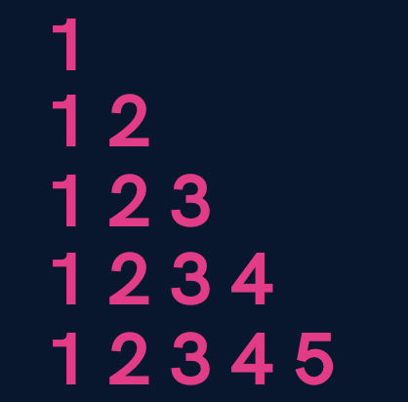

**import java.util.*;**

**public class Patterns {**

**public static void main(String args[]) {**

**int n = 5;**

**for(int i=1; i<=n; i++) {**

**for(int j=1; j<=i; j++) {**

**System.out.print(j);**

**}**

**System.out.println();**

**}**

**}**

**}**

1. 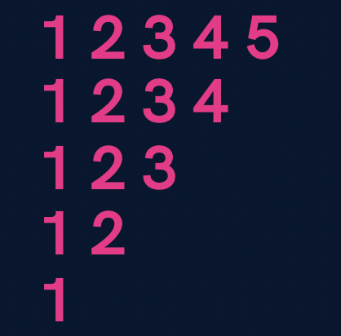

**import java.util.*;**

**public class Patterns {**

**public static void main(String args[]) {**

**int n = 5;**

**for(int i=n; i>=1; i--) {**

**for(int j=1; j<=i; j++) {**

**System.out.print(j);**

**}**

**System.out.println();**

**}**

**}**

**}**

1. 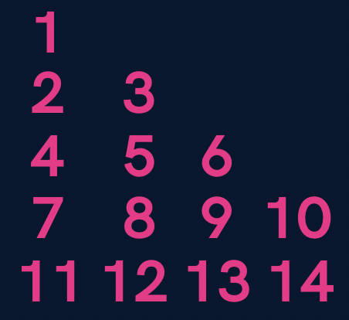

**import java.util.*;**

**public class Patterns {**

**public static void main(String args[]) {**

**int n = 5;**

**int number = 1;**

**for(int i=1; i<=n; i++) {**

**for(int j=1; j<=i; j++) {**

**System.out.print(number+" ");**

**number++;**

**}**

**System.out.println();**

**}**

**}**

**}**

1. 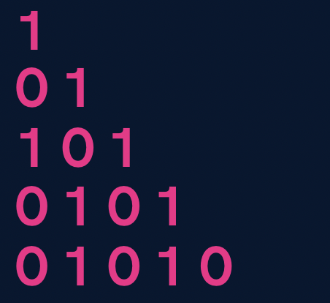

**import java.util.*;**

**public class Patterns {**

**public static void main(String args[]) {**

**int n = 5;**

**for(int i=1; i<=n; i++) {**

**for(int j=1; j<=i; j++) {**

**if((i+j) % 2 == 0) {**

**System.out.print(1+" ");**

**} else {**

**System.out.print(0+" ");**

**}**

**}**

**System.out.println();**

**}**

**}**

**}**

**Homework Problems (Solutions in next Lecture’s Video)**

1. Print a solid rhombus.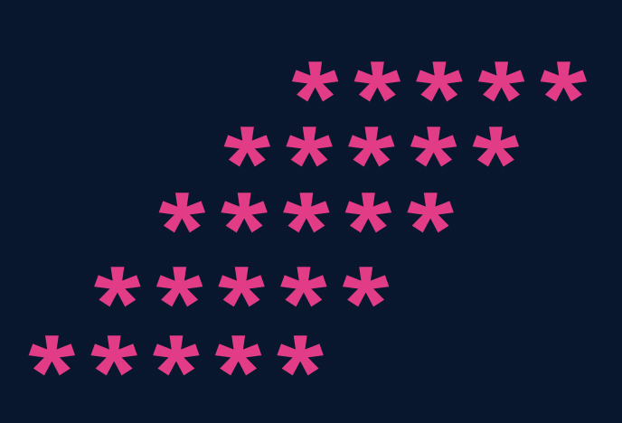
2. Print a number pyramid.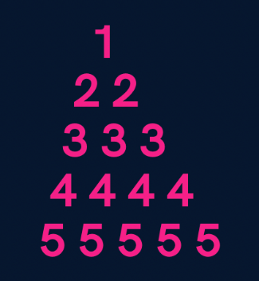
3. Print a palindromic number pyramid.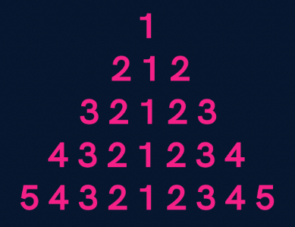

**Homework Solution (Lecture 4)**

1. Print all even numbers till n.
2. public class Solutions {
3. public static void main(String args[]) {
4. int n = 25;
5. for(int i=1; i<=n; i++) {
6. if(i % 2 == 0) {
7. System.out.println(i);
8. }
9. }
10. }
11. }

3. Make a menu driven program. The user can enter 2 numbers, either 1 or 0.

If the user enters 1 then keep taking input from the user for a student’s marks (out of 100).

If they enter 0 then stop.

If he/ she scores:

**Marks >=90** -> print “This is Good”

**89 >= Marks >= 60** -> print “This is also Good”

**59 >= Marks >= 0** -> print “This is Good as well”

        Because marks don’t matter but our effort does.

(Hint: use do-while loop but think & understand why)

**import java.util.*;**

**public class Solutions {**

**public static void main(String args[]) {**

**Scanner sc = new Scanner(System.in);**

**int input;**

**do {**

**int marks = sc.nextInt();**

**if(marks >= 90 && marks <= 100) {**

**System.out.println("This is Good");**

**} else if(marks >= 60 && marks <= 89) {**

**System.out.println("This is also Good");**

**} else if(marks >= 0 && marks <= 59) {**

**System.out.println("This is Good as well");**

**} else {**

**System.out.println("Invalid");**

**}**

**System.out.println("Want to continue ? (yes(1) or no(0))");**

**input = sc.nextInt();**

**} while(input == 1);**

**}**

**}**

Qs. Print if a number n is prime or not (Input n from the user).

[In this problem you will learn how to check if a number is prime or not]

**import java.util.*;**

**public class Solutions {**

**public static void main(String args[]) {**

**Scanner sc = new Scanner(System.in);**

**int n = sc.nextInt();**

**boolean isPrime = true;**

**for(int i=2; i<=n/2; i++) {**

**if(n % i == 0) {**

**isPrime = false;**

**break;**

**}**

**}**

**if(isPrime) {**

**if(n == 1) {**

**System.out.println("This is neither prime not composite");**

**} else {**

**System.out.println("This is a prime number");**

**}**

**} else {**

**System.out.println("This is not a prime number");**

**}**

**}**

**}**

**Java - Introduction to Programming**

**Lecture 6**

**Patterns - Part 2**

1. 

import java.util.*;

public class Solutions {

   public static void main(String args[]) {

       int n = 4;

       //upper part

       for(int i=1; i<=n; i++) {

           for(int j=1; j<=i; j++) {

               System.out.print("*");

           }

           int spaces = 2 * (n-i);

           for(int j=1; j<=spaces; j++) {

               System.out.print(" ");

           }

           for(int j=1; j<=i; j++) {

               System.out.print("*");

           }

           System.out.println();

       }

       //lower part

       for(int i=n; i>=1; i--) {

           for(int j=1; j<=i; j++) {

               System.out.print("*");

           }

           int spaces = 2 * (n-i);

           for(int j=1; j<=spaces; j++) {

               System.out.print(" ");

           }

           for(int j=1; j<=i; j++) {

               System.out.print("*");

           }

           System.out.println();

       }

   }

}

2. 

import java.util.*;

public class Solutions {

   public static void main(String args[]) {

       int n = 5;

       for(int i=1; i<=n; i++) {

           //spaces

           for(int j=1; j<=n-i; j++) {

               System.out.print(" ");

           }

           //stars

           for(int j=1; j<=n; j++) {

               System.out.print("*");

           }

           System.out.println();

       }

   }

}

3. 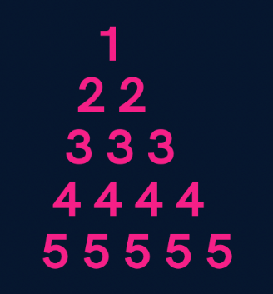

import java.util.*;

public class Solutions {

   public static void main(String args[]) {

       int n = 5;

       for(int i=1; i<=n; i++) {

           //spaces

           for(int j=1; j<=n-i; j++) {

               System.out.print(" ");

           }

           //numbers

           for(int j=1; j<=i; j++) {

               System.out.print(i+" ");

           }

           System.out.println();

       }

   }

}

4. 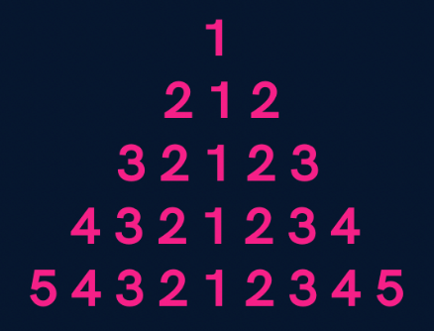

import java.util.*;

public class Solutions {

   public static void main(String args[]) {

       int n = 5;

       for(int i=1; i<=n; i++) {

           //spaces

           for(int j=1; j<=n-i; j++) {

               System.out.print(" ");

           }

           //first part

           for(int j=i; j>=1; j--) {

               System.out.print(j);

           }

           //second part

           for(int j=2; j<=i; j++) {

               System.out.print(j);

           }

           System.out.println();

       }

   }

}

5. 

import java.util.*;

public class Solutions {

   public static void main(String args[]) {

       int n = 5;

       //upper part

       for(int i=1; i<=n; i++) {

           //spaces

           for(int j=1; j<=n-i; j++) {

               System.out.print(" ");

           }

           for(int j=1; j<=2*i-1; j++) {

               System.out.print("*");

           }

           System.out.println();

       }

       //lower part

       for(int i=n; i>=1; i--) {

           //spaces

           for(int j=1; j<=n-i; j++) {

               System.out.print(" ");

           }

           for(int j=1; j<=2*i-1; j++) {

               System.out.print("*");

           }

           System.out.println();

       }

   }

}

**Homework Problems**

1. **Print a hollow Butterfly.**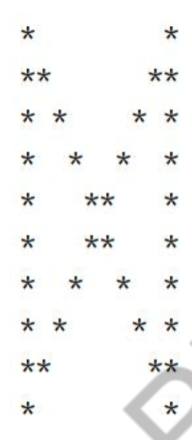
2. **Print a hollow Rhombus.**

    *****

   *      *

  *     *

 *     *

*****

1. **Print Pascal’s Triangle.**

    1

   1 1

  1 2 1

 1 3 3 1

1 4 6 4 1

1. **Print half Pyramid.**

    1

   1 2

  1 2 3

 1 2 3 4

* 1. 2 3 4 5

1. **Print Inverted Half Pyramid.**

11111

222

33

4

**Java - Introduction to Programming**

**Lecture 7**

**Methods/Functions**

A function is a block of code that performs a specific task.

Why are functions used?

1. If some functionality is performed at multiple places in software, then rather than writing the same code, again and again, we create a function and call it everywhere. This helps reduce code redundancy.
2. Functions make maintenance of code easy as we have to change at one place if we make future changes to the functionality.
3. Functions make the code more readable and easier to understand.

The **syntax** for function declaration is:

return-type function name (parameter 1, parameter2, …… parameter n) {  //function body

}

return-type

The **return type** of a function is the data type of the variable that that function returns.

For eg - If we write a function that adds 2 integers and returns their sum then the return type of this function will be ‘int’ as we will return a sum that is an integer value.

When a function does not return any value, in that case the return type of the function is ‘void’.

**function name**

It is the unique name of that function.

It is always recommended to declare a function before it is used.

**Parameters**

A function can take some parameters as inputs. These parameters are specified along with their data types.

For eg- if we are writing a function to add 2 integers, the parameters would be passed like –

int add (int num1, int num2)

**main function**

The main function is a special function as the computer starts running the code from the beginning of the main function. Main function serves as the entry point for the program.

**Example**:

package com.apnacollege;

public class Main {

   //A METHOD to calculate sum of 2 numbers - a & b

   public static void sum(int a, int b) {

       int sum = a + b;

       System.*out*.println(sum);

   }

   public static void main(String[] args) {

      int a = 10;

      int b = 20;

*sum*(a, b); // Function Call

   }

}

**Qs. Write a function to multiply 2 numbers.**

**import java.util.*;**

**public class Functions {**

**//Multiply 2 numbers**

**public static int multiply(int a, int b) {**

**return a*b;**

**}**

**public static void main(String args[]) {**

**Scanner sc = new Scanner(System.in);**

**int a = sc.nextInt();**

**int b = sc.nextInt();**

**int result = multiply(a, b);**

**System.out.println(result);**

**}**

**}**

**Qs. Write a function to calculate the factorial of a number.**

**Import java.util.*;**

**public class Functions {**

**// public static int calculateSum(int a, int b) {**

**//     int sum = a + b;**

**//     return sum;**

**// }**

**// public static int calculateProduct(int a, int b) {**

**//    return a * b;**

**// }**

**public static void printFactorial(int n) {**

**//loop**

**if(n < 0) {**

**System.out.println("Invalid Number");**

**return;**

**}**

**int factorial = 1;**

**for(int i=n; i>=1; i--) {**

**factorial = factorial * i;**

**}**

**System.out.println(factorial);**

**return;**

**}**

**public static void main(String args[]) {**

**Scanner sc = new Scanner(System.in);**

**int n = sc.nextInt();**

**printFactorial(n);**

**}**

**}**

**Qs. Write a function to calculate the product of 2 numbers.**

**import java.util.*;**

**public class Functions {**

**// public static int calculateSum(int a, int b) {**

**//     int sum = a + b;**

**//     return sum;**

**// }**

**public static int calculateProduct(int a, int b) {**

**return a * b;**

**}**

**public static void main(String args[]) {**

**Scanner sc = new Scanner(System.in);**

**int a = sc.nextInt();**

**int b = sc.nextInt();**

**System.out.println(calculateProduct(a, b));**

**}**

**}**

**Homework Problems**

1. **Make a function to check if a number is prime or not.**
2. **Make a function to check if a given number n is even or not.**
3. **Make a function to print the table of a given number n.**
4. **Read about Recursion.**

**Java - Introduction to Programming**

**Exercise 1**

**Questions**

1. Enter 3 numbers from the user & make a function to print their average.
2. Write a function to print the sum of all odd numbers from 1 to n.
3. Write a function which takes in 2 numbers and returns the greater of those two.
4. Write a function that takes in the radius as input and returns the circumference of a circle.
5. Write a function that takes in age as input and returns if that person is eligible to vote or not. A person of age > 18 is eligible to vote.
6. Write an infinite loop using do while condition.
7. Write a program to enter the numbers till the user wants and at the end it should display the count of positive, negative and zeros entered.
8. Two numbers are entered by the user, x and n. Write a function to find the value of one number raised to the power of another i.e. xn.
9. Write a function that calculates the Greatest Common Divisor of 2 numbers. (BONUS)
10. Write a program to print Fibonacci series of n terms where n is input by user:

0 1 1 2 3 5 8 13 21 ....

In the Fibonacci series, a number is the sum of the previous 2 numbers that came before it.

(BONUS)

**Java - Introduction to Programming**

**Exercise 1 SOLUTIONS**

1. Enter 3 numbers from the user & make a function to print their average.

//Try to convert it into a function on your own.

import java.util.*;

public class Solutions {

   public static void main(String args[]) {

      Scanner sc = new Scanner(System.in);

      int a = sc.nextInt();

      int b = sc.nextInt();

      int c = sc.nextInt();

      int average = (a + b + c) / 3;

      System.out.println(average);

   }

}

1. Write a function to print the sum of all odd numbers from 1 to n.

import java.util.*;

public class Solutions {

   public static void printSum(int n) {

       int sum = 0;

      for(int i=1; i<=n; i++) {

        if(i % 2 != 0) {

            sum = sum + i;

        }

      }

      System.out.println(sum);

   }

   public static void main(String args[]) {

      Scanner sc = new Scanner(System.in);

      int n = sc.nextInt();

      printSum(n);

   }

}

1. Write a function which takes in 2 numbers and returns the greater of those two.

import java.util.*;

public class Solutions {

   public static int getGreater(int a, int b) {

      if(a > b) {

          return a;

      } else {

          return b;

      }

   }

   public static void main(String args[]) {

      Scanner sc = new Scanner(System.in);

      int a = sc.nextInt();

      int b = sc.nextInt();

      System.out.println(getGreater(a, b));

   }

}

1. Write a function that takes in the radius as input and returns the circumference of a circle.

import java.util.*;

public class Solutions {

   public static Double getCircumference(Double radius) {

       return 2 * 3.14 * radius;

   }

   public static void main(String args[]) {

      Scanner sc = new Scanner(System.in);

      Double r = sc.nextDouble();

      System.out.println(getCircumference(radius));

   }

}

1. Write a function that takes in age as input and returns if that person is eligible to vote or not. A person of age > 18 is eligible to vote.

import java.util.*;

public class Solutions {

   public static boolean isElligible(int age) {

       if(age > 18) {

           return true;

       }

       return false;

   }

   public static void main(String args[]) {

      Scanner sc = new Scanner(System.in);

      int age = sc.nextInt();

      System.out.println(isElligible(age));

   }

}

1. Write an infinite loop using do while condition.

import java.util.*;

public class Solutions {

   public static void main(String args[]) {

      do {

      } while(true);

   }

}

1. Write a program to enter the numbers till the user wants and at the end it should display the count of positive, negative and zeros entered.

import java.util.*;

public class Solutions {

   public static void main(String args[]) {

       int positive = 0, negative = 0, zeros = 0;

       System.out.println("Press 1 to continue & 0 to stop");

       Scanner sc = new Scanner(System.in);

       int input = sc.nextInt();

       while(input == 1) {

           System.out.println("Enter your number : ");

           int number = sc.nextInt();

           if(number > 0) {

               positive++;

           } else if(number < 0) {

               negative++;

           } else {

               zeros++;

           }

           System.out.println("Press 1 to continue & 0 to stop");

           input = sc.nextInt();

       }

       System.out.println("Positives : "+ positive);

       System.out.println("Negatives : "+ negative);

       System.out.println("Zeros : "+ zeros);

   }

}

1. Two numbers are entered by the user, x and n. Write a function to find the value of one number raised to the power of another i.e. xn.

//Try to convert it into a function on your own.

import java.util.*;

public class Solutions {

   public static void main(String args[]) {

       System.out.println("Enter x");

       Scanner sc = new Scanner(System.in);

       int x = sc.nextInt();

       System.out.println("Enter n");

       int n = sc.nextInt();

       int result = 1;

       //Please see that n is not too large or else result will exceed the size of int

       for(int i=0; i<n; i++) {

           result = result * x;

       }

       System.out.println("x to the power n is : "+ result);

   }

}

1. Write a function that calculates the Greatest Common Divisor of 2 numbers. (BONUS)

import java.util.*;

public class Solutions {

   public static void main(String args[]) {

       Scanner sc = new Scanner(System.in);

       int n1 = sc.nextInt();

       int n2 = sc.nextInt();

       while(n1 != n2) {

           if(n1>n2) {

               n1 = n1 - n2;

           } else {

               n2 = n2 - n1;

           }

       }

       System.out.println("GCD is : "+ n2);

   }

}

//Try to convert it into a function on your own.

1. Write a program to print Fibonacci series of n terms where n is input by user:

0 1 1 2 3 5 8 13 21 ....

In the Fibonacci series, a number is the sum of the previous 2 numbers that came before it.

(BONUS)

import java.util.*;

public class Solutions {

   public static void main(String args[]) {

       Scanner sc = new Scanner(System.in);

       int n = sc.nextInt();

       int a = 0, b = 1;

       System.out.print(a+" ");

       if(n > 1) {

           //find nth term

           for(int i=2; i<=n; i++) {

               System.out.print(b+" ");

               //the concept below is called swapping

               int temp = b;

               b = a + b;

               a = temp;

           }

           System.out.println();

       }

   }

}

**Java - Introduction to Programming**

**Lecture 8**

**Time & Space Complexity**

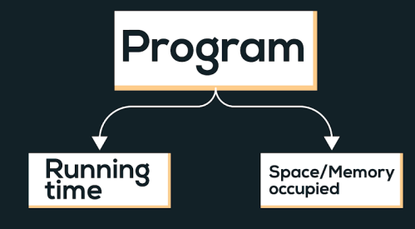

Time complexity of an algorithm quantifies the amount of time taken by an algorithm to run as a function of the length of the input.

Types of notations

1. O-notation: It is used to denote asymptotic upper bound. For a given function g(n), we denote it by O(g(n)). Pronounced as “big-oh of g of n”. It is also known as worst case time complexity as it denotes the upper bound in which the algorithm terminates.

2. Ω-notation: It is used to denote asymptotic lower bound. For a given function g(n), we denote it by Ω(g(n)). Pronounced as “big-omega of g of n”. It is also known as best case time complexity as it denotes the lower bound in which the algorithm terminates.

3. 𝚯-notation: It is used to denote the average time of a program.

**Examples:**  
  
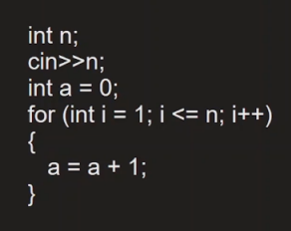

Linear Time Complexity. O(n)

**Comparison of functions on the basis of time complexity**

It follows the following order in case of time complexity:

O(nn) > O(n!) > O(n3) > O(n2) > O(n.log(n)) > O(n.log(log(n))) > O(n) > O(sqrt(n)) > O(log(n)) > O(1)

Note: Reverse is the order for better performance of a code with corresponding time complexity, i.e. a program with less time complexity is more efficient.

**Space Complexity**

Space complexity of an algorithm quantifies the amount of time taken by a program to run as a function of length of the input. It is directly proportional to the largest memory your program acquires at any instance during run time.

For example: *int* consumes 4 bytes of memory.

**Java - Introduction to Programming**

**Lecture 10**

**Arrays In Java**

Arrays in Java are like a list of elements of the same type i.e. a list of integers, a list of Booleans etc.

1. Creating an Array (method 1) - with new keyword

int[] marks = new int[3];

marks[0] = 97;

marks[1] = 98;

marks[2] = 95;

1. Creating an Array (method 2)

**int[] marks = {98, 97, 95};**

1. Taking an array as an input and printing its elements.

import java.util.*;

public class Arrays {

   public static void main(String args[]) {

       Scanner sc = new Scanner(System.in);

       int size = sc.nextInt();

       int numbers[] = new int[size];

       for(int i=0; i<size; i++) {

           numbers[i] = sc.nextInt();

       }

       //print the numbers in array

       for(int i=0; i<arr.length; i++) {

           System.out.print(numbers[i]+" ");

       }

   }

}

**Homework Problems**

1. Take an array of names as input from the user and print them on the screen.

import java.util.*;

public class Arrays {

   public static void main(String args[]) {

      Scanner sc = new Scanner(System.in);

      int size = sc.nextInt();

      String names[] = new String[size];

      //input

      for(int i=0; i<size; i++) {

          names[i] = sc.next();

      }

      //output

       for(int i=0; i<names.length; i++) {

           System.out.println("name " + (i+1) +" is : " + names[i]);

       }

   }

}

1. Find the maximum & minimum number in an array of integers.

[HINT: Read about Integer.MIN_VALUE & Integer.MAX_VALUE in Java]

import java.util.*;

public class Arrays {

   public static void main(String args[]) {

      Scanner sc = new Scanner(System.in);

      int size = sc.nextInt();

      int numbers[] = new int[size];

      //input

      for(int i=0; i<size; i++) {

          numbers[i] = sc.nextInt();

      }

      int max = Integer.MIN_VALUE;

      int min = Integer.MAX_VALUE;

       for(int i=0; i<numbers.length; i++) {

           if(numbers[i] < min) {

               min = numbers[i];

           }

           if(numbers[i] > max) {

               max = numbers[i];

           }

       }

       System.out.println("Largest number is : " + max);

       System.out.println("Smallest number is : " + min);

   }

}

1. Take an array of numbers as input and check if it is an array sorted in ascending order.

Eg: { 1, 2, 4, 7 } is sorted in ascending order.

       {3, 4, 6, 2} is not sorted in ascending order.

import java.util.*;

public class Arrays {

   public static void main(String args[]) {

      Scanner sc = new Scanner(System.in);

      int size = sc.nextInt();

      int numbers[] = new int[size];

      //input

      for(int i=0; i<size; i++) {

          numbers[i] = sc.nextInt();

      }

      boolean isAscending = true;

       for(int i=0; i<numbers.length-1; i++) { // NOTICE numbers.length - 1 as termination condition

           if(numbers[i] > numbers[i+1]) { // This is the condition for descending order

               isAscending = false;

           }

       }

       if(isAscending) {

           System.out.println("The array is sorted in ascending order");

       } else {

           System.out.println("The array is not sorted in ascending order");

       }

   }

}

**Java - Introduction to Programming**

**Lecture 11**

**2D Arrays in Java**

It is similar to 2D matrices that we studied in 11th and 12th class.

1. Creating a 2D Array - with new keyword

int[][] marks = new int[3][3];

1. Taking a matrix as an input and printing its elements.

import java.util.*;

public class TwoDArrays {

   public static void main(String args[]) {

       Scanner sc = new Scanner(System.in);

       int rows = sc.nextInt();

       int cols = sc.nextInt();

       int[][] numbers = new int[rows][cols];

       //input

       //rows

       for(int i=0; i<rows; i++) {

           //columns

           for(int j=0; j<cols; j++) {

               numbers[i][j] = sc.nextInt();

           }

       }

       for(int i=0; i<rows; i++) {

           for(int j=0; j<cols; j++) {

                   System.out.print(numbers[i][j]+" ");

               }

               System.out.println();

           }

   }

**}**

1. Searching for an element x in a matrix.

**import java.util.*;**

**public class TwoDArrays {**

**public static void main(String args[]) {**

**Scanner sc = new Scanner(System.in);**

**int rows = sc.nextInt();**

**int cols = sc.nextInt();**

**int[][] numbers = new int[rows][cols];**

**//input**

**//rows**

**for(int i=0; i<rows; i++) {**

**//columns**

**for(int j=0; j<cols; j++) {**

**numbers[i][j] = sc.nextInt();**

**}**

**}**

**int x = sc.nextInt();**

**for(int i=0; i<rows; i++) {**

**for(int j=0; j<cols; j++) {**

**//compare with x**

**if(numbers[i][j] == x) {**

**System.out.println("x found at location (" + i + ", " + j + ")");**

**}**

**}**

**}**

**}**

**}**

**Homework Problems**

1. Print the spiral order matrix as output for a given matrix of numbers. [Difficult for Beginners]  
   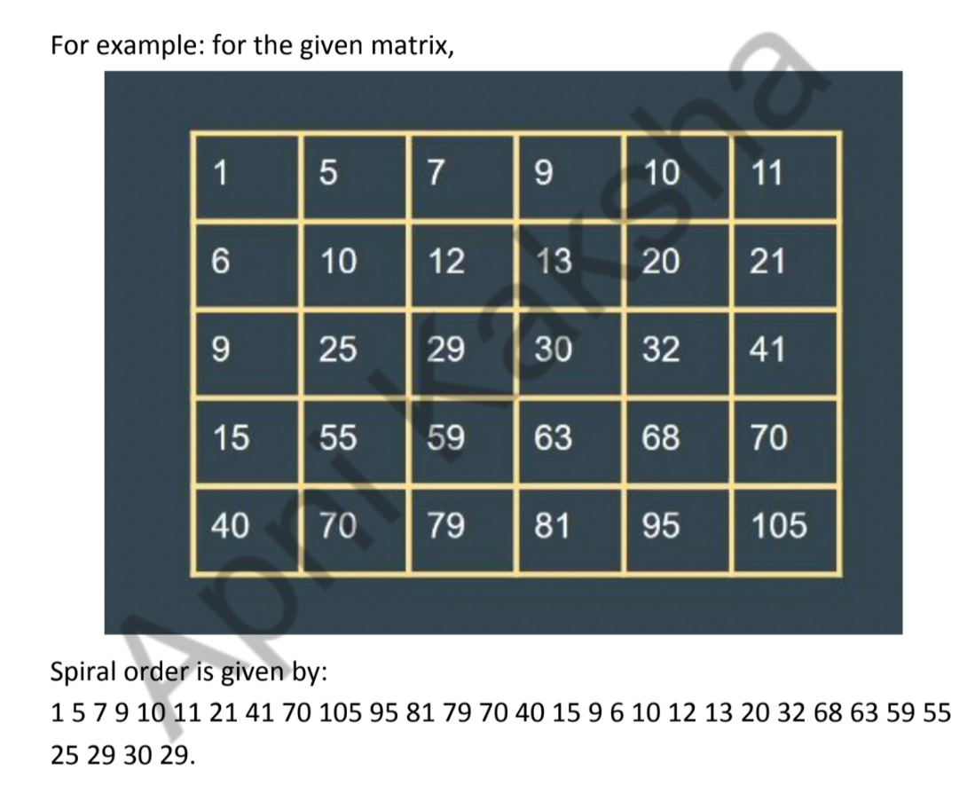

**APPROACH**:

Algorithm: (We are given a 2D matrix of n X m).

*1. We will need 4 variables:*

*a. row_start - initialized with 0.*

*b. row_end - initialized with n-1.*

*c. column_start - initialized with 0.*

*d. column_end - initialized with m-1.*

*2. First of all, we will traverse in the row row_start from column_start*

*to column_end and we will increase the row_start with 1 as we have*

*traversed the starting row.*

*3. Then we will traverse in the column column_end from row_start to*

*row_end and decrease the column_end by 1.*

*4. Then we will traverse in the row row_end from column_end to*

*column_start and decrease the row_end by 1.*

*5. Then we will traverse in the column column_start from row_end to*

*row_start and increase the column_start by 1.*

*6. We will do the above steps from 2 to 5 until row_start <= row_end*

*and column_start <= column_end.*

import java.util.*;

public class Arrays {

   public static void main(String args[]) {

      Scanner sc = new Scanner(System.in);

      int n = sc.nextInt();

      int m = sc.nextInt();

      int matrix[][] = new int[n][m];

      for(int i=0; i<n; i++) {

           for(int j=0; j<m; j++) {

               matrix[i][j] = sc.nextInt();

           }

      }

      System.out.println("The Spiral Order Matrix is : ");

      int rowStart = 0;

      int rowEnd = n-1;

      int colStart = 0;

      int colEnd = m-1;

      //To print spiral order matrix

      while(rowStart <= rowEnd && colStart <= colEnd) {

          //1

          for(int col=colStart; col<=colEnd; col++) {

              System.out.print(matrix[rowStart][col] + " ");

          }

          rowStart++;

          //2

          for(int row=rowStart; row<=rowEnd; row++) {

              System.out.print(matrix[row][colEnd] +" ");

          }

          colEnd--;

          //3

          for(int col=colEnd; col>=colStart; col--) {

              System.out.print(matrix[rowEnd][col] + " ");

          }

          rowEnd--;

          //4

          for(int row=rowEnd; row>=rowStart; row--) {

              System.out.print(matrix[row][colStart] + " ");

          }

          colStart++;

          System.out.println();

      }

   }

}

1. For a given matrix of N x M, print its transpose.

import java.util.*;

public class Arrays {

   public static void main(String args[]) {

      Scanner sc = new Scanner(System.in);

      int n = sc.nextInt();

      int m = sc.nextInt();

      int matrix[][] = new int[n][m];

      for(int i=0; i<n; i++) {

           for(int j=0; j<m; j++) {

               matrix[i][j] = sc.nextInt();

           }

      }

      System.out.println("The transpose is : ");

      //To print transpose

      for(int j=0; j<m ;j++) {

          for(int i=0; i<n; i++) {

              System.out.print(matrix[i][j]+" ");

          }

          System.out.println();

      }

   }

}

**Java - Introduction to Programming**

**Lecture 12**

**Strings**

**Declaration**

**String name = "Tony";**

**Taking Input**

**Scanner sc = new Scanner(System.in);**

**String name = sc.next();**

**Concatenation (Joining 2 strings)**

**String firstName = "Tony";**

**String secondName = "Stark";**

**String fullName = firstName + " " + secondName;**

**System.out.println(fullName);**

**Print length of a String**

**String firstName = "Tony";**

**String secondName = "Stark";**

**String fullName = firstName + " " + secondName;**

**System.out.println(fullName.length());**

**Access characters of a string**

**String firstName = "Tony";**

**String secondName = "Stark";**

**String fullName = firstName + " " + secondName;**

**for(int i=0; i<fullName.length(); i++) {**

**System.out.println(fullName.charAt(i));**

**}**

**Compare 2 strings**

**import java.util.*;**

**public class Strings {**

**public static void main(String args[]) {**

**String name1 = "Tony";**

**String name2 = "Tony";**

**if(name1.equals(name2)) {**

**System.out.println("They are the same string");**

**} else {**

**System.out.println("They are different strings");**

**}**

**//DO NOT USE == to check for string equality**

**//Gives correct answer here**

**if(name1 == name2) {**

**System.out.println("They are the same string");**

**} else {**

**System.out.println("They are different strings");**

**}**

**//Gives incorrect answer here**

**if(new String("Tony") == new String("Tony")) {**

**System.out.println("They are the same string");**

**} else {**

**System.out.println("They are different strings");**

**}**

**}**

**}**

**Substring**

The substring of a string is a subpart of it.

public class Strings {

   public static void main(String args[]) {

       String name = "TonyStark";

       System.out.println(name.substring(0, 4));

   }

}

**ParseInt Method of Integer class**

**public class Strings {**

**public static void main(String args[]) {**

**String str = "123";**

**int number = Integer.parseInt(str);**

**System.out.println(number);**

**}**

**}**

**ToString Method of String class**

**public class Strings {**

**public static void main(String args[]) {**

**int number = 123;**

**String str = Integer.toString(number);**

**System.out.println(str.length());**

**}**

**}**

**ALWAYS REMEMBER: Java Strings are Immutable.**

**Homework Problems**

1. Take an array of Strings input from the user & find the cumulative (combined) length of all those strings.

import java.util.*;

public class Strings {

   public static void main(String args[]) {

     Scanner sc = new Scanner (System.in);

     int size = sc.nextInt();

     String array[] = new String[size];

     int totLength = 0;

     for(int i=0; i<size; i++) {

       array[i] = sc.next();

       totLength += array[i].length();

     }

     System.out.println(totLength);

   }

}

1. Input a string from the user. Create a new string called ‘result’ in which you will replace the letter ‘e’ in the original string with letter ‘i’.

Example:

original = “eabcdef’; result = “iabcdif”

Original = “xyz”; result = “xyz”

import java.util.*;

public class Strings {

   public static void main(String args[]) {

     Scanner sc = new Scanner (System.in);

     String str = sc.next();

     String result = "";

     for(int i=0; i<str.length(); i++) {

       if(str.charAt(i) == 'e') {

         result += 'i';

       } else {

         result += str.charAt(i);

       }

     }

     System.out.println(result);

   }

}

1. Input an email from the user. You have to create a username from the email by deleting the part that comes after ‘@’. Display that username to the user.

Example:

email = “[apnaCollegeJava@gmail.com](mailto:apnacollegeJava@gmail.com)”; username = “apnaCollegeJava”

email = “[helloWorld123@gmail.com](mailto:helloWorlds123@gmail.com)”; username = “helloWorld123”

import java.util.*;

public class Strings {

   public static void main(String args[]) {

     Scanner sc = new Scanner (System.in);

     String email = sc.next();

     String userName = "";

     for(int i=0; i<email.length(); i++) {

       if(email.charAt(i) == '@') {

        break;

       } else {

         userName += email.charAt(i);

       }

     }

     System.out.println(userName);

   }

}

**Java - Introduction to Programming**

**Lecture 13**

**String Builder**

**Declaration**

**StringBuilder sb = new StringBuilder("Apna College");**

**System.out.println(sb);**

**Get A Character from Index**

**StringBuilder sb = new StringBuilder("Tony");**

**//Set Char**

**System.out.println(sb.charAt(0));**

**Set a Character at Index**

**StringBuilder sb = new StringBuilder("Tony");**

**//Get Char**

**sb.setCharAt(0, 'P');**

**System.out.println(sb);**

**Insert a Character at Some Index**

**import java.util.*;**

**public class Strings {**

**public static void main(String args[]) {**

**StringBuilder sb = new StringBuilder("tony");**

**//Insert char**

**sb.insert(0, 'S');**

**System.out.println(sb);**

**}**

**}**

**Delete char at some Index**

**import java.util.*;**

**public class Strings {**

**public static void main(String args[]) {**

**StringBuilder sb = new StringBuilder("tony");**

**//Insert char**

**sb.insert(0, 'S');**

**System.out.println(sb);**

**//delete char**

**sb.delete(0, 1);**

**System.out.println(sb);**

**}**

**}**

**Append a char**

Append means to add something at the end.

import java.util.*;

public class Strings {

   public static void main(String args[]) {

     StringBuilder sb = new StringBuilder("Tony");

     sb.append(" Stark");

     System.out.println(sb);

   }

}

**Print Length of String**

**import java.util.*;**

**public class Strings {**

**public static void main(String args[]) {**

**StringBuilder sb = new StringBuilder("Tony");**

**sb.append(" Stark");**

**System.out.println(sb);**

**System.out.println(sb.length());**

**}**

**}**

**Reverse a String (using StringBuilder class)**

**import java.util.*;**

**public class Strings {**

**public static void main(String args[]) {**

**StringBuilder sb = new StringBuilder("HelloWorld");**

**for(int i=0; i<sb.length()/2; i++) {**

**int front = i;**

**int back = sb.length() - i - 1;**

**char frontChar = sb.charAt(front);**

**char backChar = sb.charAt(back);**

**sb.setCharAt(front, backChar);**

**sb.setCharAt(back, frontChar);**

**}**

**System.out.println(sb);**

**}**

**}**

**Homework Problems**

Try Solving all the String questions with StringBuilder.

**Java - Introduction to Programming**

**Lecture 14**

**Bit Manipulation**

**Get Bit**

**import java.util.*;**

**public class Bits {**

**public static void main(String args[]) {**

**int n = 5; //0101**

**int pos = 3;**

**int bitMask = 1<<pos;**

**if((bitMask & n) == 0) {**

**System.out.println("bit was zero");**

**} else {**

**System.out.println("bit was one");**

**}**

**}**

**}**

**Set Bit**

**import java.util.*;**

**public class Bits {**

**public static void main(String args[]) {**

**int n = 5; //0101**

**int pos = 1;**

**int bitMask = 1<<pos;**

**int newNumber = bitMask | n;**

**System.out.println(newNumber);**

**}**

**}**

**Clear Bit**

**import java.util.*;**

**public class Bits {**

**public static void main(String args[]) {**

**int n = 5; //0101**

**int pos = 2;**

**int bitMask = 1<<pos;**

**int newBitMask = ~(bitMask);**

**int newNumber = newBitMask & n;**

**System.out.println(newNumber);**

**}**

**}**

**Update Bit**

import java.util.*;

public class Bits {

   public static void main(String args[]) {

       Scanner sc = new Scanner(System.in);

       int oper = sc.nextInt();

       // oper=1 -> set; oper=0 -> clear

      int n = 5;

      int pos = 1;

      int bitMask = 1<<pos;

      if(oper == 1) {

          //set

          int newNumber = bitMask | n;

          System.out.println(newNumber);

      } else {

       //clear

       int newBitMask = ~(bitMask);

       int newNumber = newBitMask & n;

       System.out.println(newNumber);

      }

   }

}

**Homework Problems**

1. Write a program to find if a number is a power of 2 or not.
2. Write a program to toggle a bit a position = “pos” in a number “n”.
3. Write a program to count the number of 1’s in a binary representation of the number.
4. Write 2 functions => decimalToBinary() & binaryToDecimal() to convert a number from one number system to another. [BONUS]

**Sorting in JAVA**

1. **Bubble Sort**

Idea: if arr[i] > arr[i+1] swap them. To place the element in their respective position, we have to do the following operation N-1 times.

Time Complexity: O(N2)

**Code**

import java.util.*;

class Sorting {

   public static void printArray(int arr[]) {

       for(int i=0; i<arr.length; i++) {

           System.out.print(arr[i]+" ");

       }

       System.out.println();

   }

   public static void main(String args[]) {

       int arr[] = {7, 8, 1, 3, 2};

       //bubble sort

       for(int i=0; i<arr.length-1; i++) {

           for(int j=0; j<arr.length-i-1; j++) {

               if(arr[j] > arr[j+1]) {

                   //swap

                   int temp = arr[j];

                   arr[j] = arr[j+1];

                   arr[j+1] = temp;

               }

           }

       }

       printArray(arr);

   }

}

1. **Selection Sort**

Idea: The inner loop selects the minimum element in the unsorted array and places the elements in increasing order.

Time complexity: O(N2)

**Code**

**import java.util.*;**

**class Sorting {**

**public static void printArray(int arr[]) {**

**for(int i=0; i<arr.length; i++) {**

**System.out.print(arr[i]+" ");**

**}**

**System.out.println();**

**}**

**public static void main(String args[]) {**

**int arr[] = {7, 8, 1, 3, 2};**

**//selection sort**

**for(int i=0; i<arr.length-1; i++) {**

**int smallest = i;**

**for(int j=i+1; j<arr.length; j++) {**

**if(arr[j] < arr[smallest]) {**

**smallest = j;**

**}**

**}**

**//swap**

**int temp = arr[smallest];**

**arr[smallest] = arr[i];**

**arr[i] = temp;**

**}**

**printArray(arr);**

**}**

**}**

1. **Insertion Sort**

Idea: Take an element from the unsorted array, place it in its corresponding position in the sorted part, and shift the elements accordingly.

Time Complexity: O(N2)

**Code**

**import java.util.*;**

**class Sorting {**

**public static void printArray(int arr[]) {**

**for(int i=0; i<arr.length; i++) {**

**System.out.print(arr[i]+" ");**

**}**

**System.out.println();**

**}**

**public static void main(String args[]) {**

**int arr[] = {7, 8, 1, 3, 2};**

**//insertion sort**

**for(int i=1; i<arr.length; i++) {**

**int current = arr[i];**

**int j = i - 1;**

**while(j >= 0 && arr[j] > current) {**

**//Keep swapping**

**arr[j+1] = arr[j];**

**j--;**

**}**

**arr[j+1] = current;**

**}**

**printArray(arr);**

**}**

**}**

1. **Quick Sort**

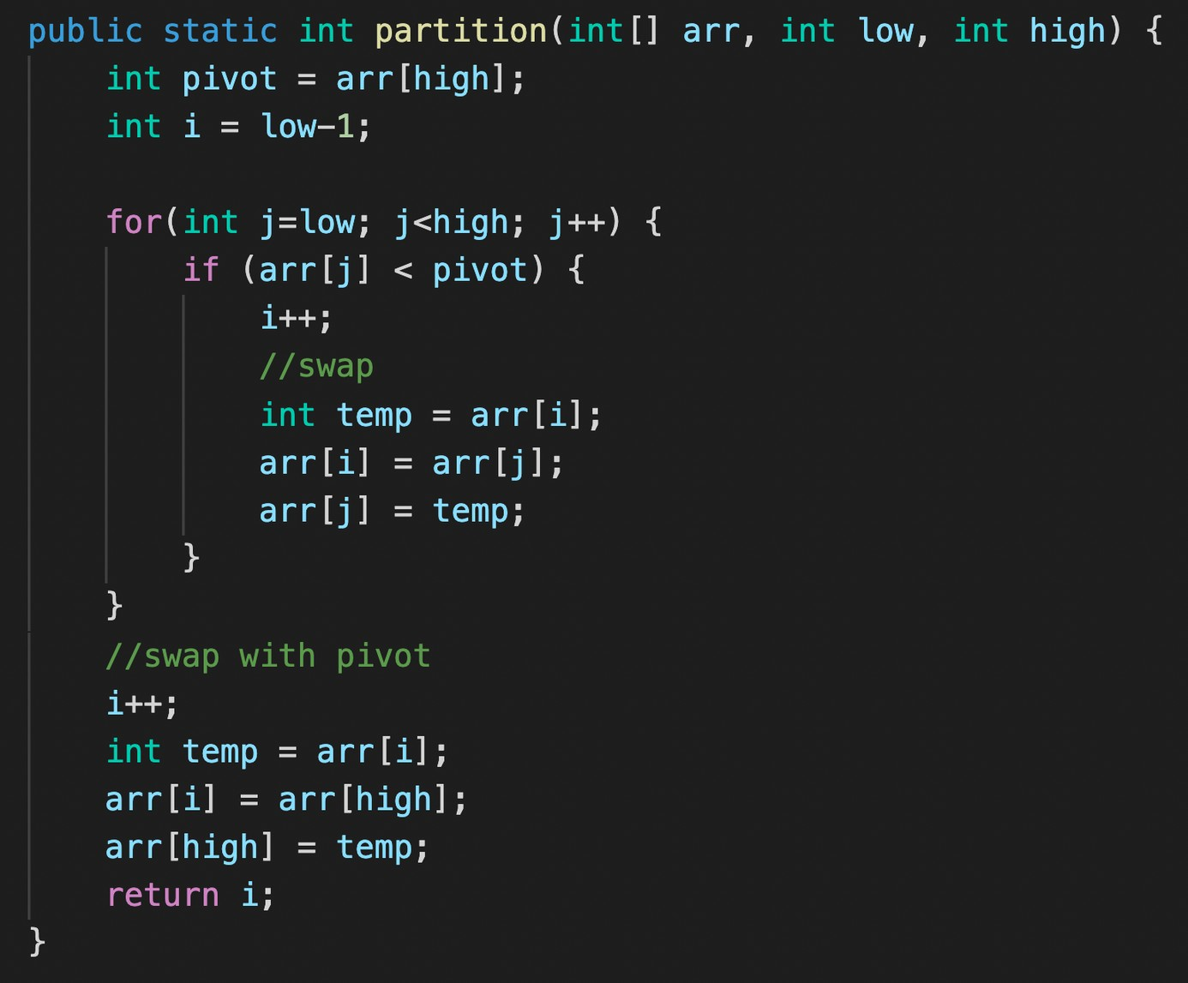

**Time complexity: -**

**Average = O(nlogn)**

**Worst = O(n^2)**

1. **Merge Sort**

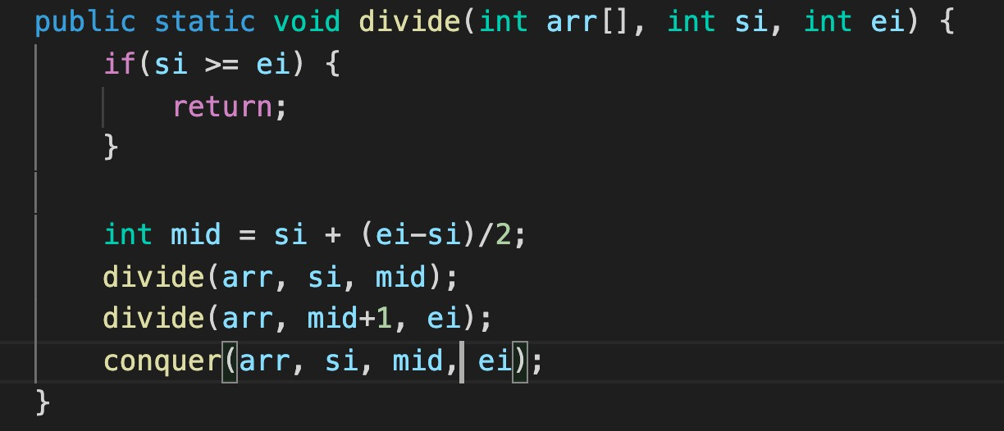

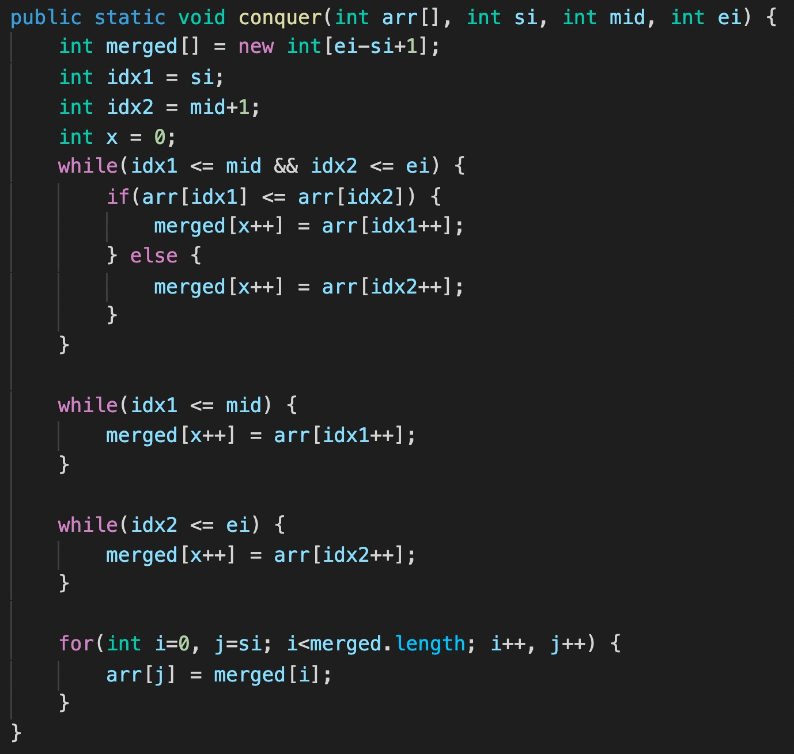**Time complexity: - O(nlogn)**

**JAVA Recursion Class 1 (Codes)**

**Q1. Print numbers from 5 to 1.**

public static void printNumbers(int n) {

if(n == 0) {

return;

}

System.out.println(n);

printNumbers(n-1);

}

**Q2. Print numbers from 1 to 5.**

public static void printNumbers(int n) {

if(n == 6) {

return;

}

System.out.println(n);

printNumbers(n+1);

}

**Q3. Print the sum of first n natural numbers.**

class Recursion1 {

public static void printSum(int n, int sum) {

if(n == 0) {

System.out.println(sum);

return;

}

sum += n;

printSum(n-1, sum);

}

public static void main(String args[]) {

printSum(5, 0);

}

}

**Q4. Print factorial of a number n.**

class Recursion1 {

public static void printFactorial(int n, int fact) {

if(n == 0) {

System.out.println(fact);

return;

}

fact *= n;

printFactorial(n-1, fact);

}

public static void main(String args[]) {

printFactorial(5, 1);

}

}

**Q5. Print the fibonacci sequence till nth term.**

class Recursion1 {

public static void printFactorial(int a, int b, int n) {

if(n == 0) {

return;

}

System.out.println(a);

printFactorial(b, a+b, n-1);

}

public static void main(String args[]) {

printFactorial(0, 1, 5);

}

}

**Q6. Print x^n (with stack height = n)**

class Recursion1 {

public static int printPower(int x, int n) {

if(n == 0) {

return 1;

}

if(x == 0) {

return 0;

}

int x_ = printPower(x, n-1);

int xn = x * x_;

return xn;

}

public static void main(String args[]) {

int x = 2, n = 5;

int output = printPower(x, n);

System.out.println(output);

}

}

**Q7. Print x^n (with stack height = logn)**

class Recursion1 {

public static int printPower(int x, int n) {

if(n == 0) {

return 1;

}

if(n % 2 == 0) {

return printPower(x, n/2) * printPower(x, n/2);

}

else {

return x * printPower(x, n/2) * printPower(x, n/2);

}

}

public static void main(String args[]) {

int x = 2, n = 5;

int output = printPower(x, n);

System.out.println(output);

}

}

**Recursion Class 2**

**Q1. Tower of Hanoi - Transfer n disks from source to destination over 3 towers.**

public class Recursion2 {

public static void towerOfHanoi(int n, String src, String helper, String dest) {

if(n == 1) {

System.out.println("transfer disk " + n + " from " + src + " to " + dest);

return;

}

//transfer top n-1 from src to helper using dest as 'helper'

towerOfHanoi(n-1, src, dest, helper);

//transfer nth from src to dest

System.out.println("transfer disk " + n + " from " + src + " to " + helper);

//transfer n-1 from helper to dest using src as 'helper'

towerOfHanoi(n-1, helper, src, dest);

}

public static void main(String args[]) {

int n = 4;

towerOfHanoi(n, "A", "B", "C");

}

}

**Q2. Print a string in reverse.**

public class Recursion2 {

public static String revString(String str) {

if(str.length() == 1) {

return str;

}

char currChar = str.charAt(0);

String nextString = revString(str.substring(1));

return nextString + currChar;

}

public static void main(String args[]) {

String str = "abcd";

String reversed = revString(str);

System.out.println(reversed);

}

}

**Q3. Find the occurrence of the first and last occurrence of an element using recursion.**

public class Recursion2 {

public static int first = -1;

public static int last = -1;

public static void getIndices(String str, char el, int idx) {

if(idx == str.length()) {

return;

}

if(str.charAt(idx) == el) {

if(first == -1) {

first = idx;

} else {

last = idx;

}

}

getIndices(str, el, idx+1);

}

public static void main(String args[]) {

String str = "tabcdfghijakkk";

char el = 'a';

getIndices(str, el, 0);

System.out.println("First occurence : " + first);

System.out.println("Last occurence : " + last);

}

}

**Q4. Check if an array is sorted (strictly increasing). - O(n)**

public class Recursion2 {

public static boolean checkIfIncreasing(int arr[], int idx) {

if(idx == arr.length-1) {

return true;

}

if(!checkIfIncreasing(arr, idx+1)) {

return false;

}

return arr[idx] < arr[idx + 1];

}

public static void main(String args[]) {

int arr1[] = {1, 2, 3, 4, 5};

int arr2[] = {1, 6, 3, 4, 5};

if(checkIfIncreasing(arr2, 0)) {

System.out.println("Strictly Increasing");

} else {

System.out.println("NOT Strictly Increasing");

}

}

}

**Q5. Move all ‘x’ to the end of the string. - O(n)**

public class Recursion2 {

//to add all 'x' to the end of the string

public static String addX(int count) {

String newStr = "x";

for(int i=1;i<count; i++) {

newStr += 'x';

}

return newStr;

}

public static String moveAllX(String str, int idx, int count) {

if(idx == str.length()) {

return addX(count);

}

if(str.charAt(idx) == 'x') {

return moveAllX(str, idx+1, count+1);

} else {

String nextStr = moveAllX(str, idx+1, count);

return str.charAt(idx) + nextStr;

}

}

public static void main(String args[]) {

String str = "abcdefxghxixjxxxk";

int count = 0;

String newStr = moveAllX(str, 0, count);

System.out.println(newStr);

}

}

**Q6. Remove duplicates in a string.**

public class Recursion2 {

public static String removeDuplicates(String str, int idx, boolean present[]) {

if(idx == str.length()) {

return "";

}

char curr = str.charAt(idx);

if(present[curr-'a']) {

return removeDuplicates(str, idx+1, present);

} else {

present[curr-'a'] = true;

return curr + removeDuplicates(str, idx+1, present);

}

}

public static void main(String args[]) {

String str = "abcadbcefghabi";

boolean present[] = new boolean[str.length()];

System.out.println(removeDuplicates(str, 0, present));

}

}

**Q7. Print all the subsequences of a string.**

public class Recursion2 {

public static void printSubseq(String str, int idx, String res) {

if(idx == str.length()) {

System.out.println(res);

return;

}

//choose

printSubseq(str, idx+1, res+str.charAt(idx));

//don't choose

printSubseq(str, idx+1, res);

}

public static void main(String args[]) {

String str1 = "abc";

String str2 = "aaa";

printSubseq(str1, 0, "");

}

}

Time complexity - O(2^n)

**Q8. Print all unique subsequences of a string.**

import java.util.HashSet;

public class Recursion2 {

public static void printSubseq(String str, int idx, String res, HashSet<String>

allSubseq) {

if(idx == str.length()) {

if(allSubseq.contains(res)) {

return;

}

allSubseq.add(res);

System.out.println(res);

return;

}

//choose

printSubseq(str, idx+1, res+str.charAt(idx), allSubseq);

//don't choose

printSubseq(str, idx+1, res, allSubseq);

}

public static void main(String args[]) {

String str1 = "abc";

String str2 = "aaa";

HashSet<String> allSubseq = new HashSet<>();

printSubseq(str2, 0, "", allSubseq);

}

}

**Q9. Print keypad combination**

( 0 -> .;

1 -> abc

2 -> def

3 -> ghi

4 -> jkl

5 -> mno

6 -> pqrs

7 -> tu

8 -> vwx

9 -> yz

)

import java.util.HashSet;

public class Recursion2 {

public static String keypad[] = {".", "abc", "def", "ghi", "jkl", "mno", "pqrs",

"tu", "vwx", "yz"};

public static void printKeypadCombination(String number, int idx, String res) {

if(idx == number.length()) {

System.out.println(res);

return;

}

for(int i=0; i<keypad[number.charAt(idx)-'0'].length(); i++) {

char curr = keypad[number.charAt(idx)-'0'].charAt(i);

printKeypadCombination(number, idx+1, res+curr);

}

}

public static void main(String args[]) {

String number = "23";

printKeypadCombination(number, 0, "");

}

}

**Recursion ADVANCED**

Q1. Print all the permutations of a string.

public class Recursion3 {

   public static void printPermutation(String str, int idx, String perm) {

       if(str.length() == 0) {

           System.out.println(perm);

           return;

       }

       for(int i=0; i<str.length(); i++) {

           char currChar = str.charAt(i);

           String newStr = str.substring(0, i) + str.substring(i+1);

           printPermutation(newStr, idx+1, perm+currChar);

       }

   }

   public static void main(String args[]) {

       String str = "abc";

       printPermutation(str, 0, "");

   }

}

Time complexity - O(n*n!)

Q2. Count Path Maze

public class Recursion3 {

   public static int countPaths(int i, int j, int m, int n) {

       if(i == m-1 || j == n-1) {

           return 1;

       }

       return countPaths(i+1, j, m, n) + countPaths(i, j+1, m, n);

   }

   public static void main(String args[]) {

       int m = 4, n = 5;

       System.out.println(countPaths(0, 0, m, n));

   }

}

Time complexity - O(2^(m+n))

Q3. Tiling problem

public class Recursion3 {

   public static int placeTiles(int n, int m) {

       if(n < m) {

           return 1;

       } else if(n == m) {

           return 2;

       }

       return placeTiles(n-1, m) + placeTiles(n-m, m);

   }

   public static void main(String args[]) {

       int n = 4, m = 4;

       System.out.println(placeTiles(n, m));

   }

}

Q4. Friends pairing problem

public class Recursion3 {

   public static int pairFriends(int n) {

      if(n <= 1) {

          return 1;

      }

       return pairFriends(n-1) + (n-1) * pairFriends(n-2);

   }

   public static void main(String args[]) {

       int n = 3;

       System.out.println(pairFriends(n));

   }

}

Q5. Subsets of a set

import java.util.ArrayList;

public class Recursion3 {

   public static void printSubsets(ArrayList<Integer> subset) {

       for(int i=0; i<subset.size(); i++) {

           System.out.print(subset.get(i)+" ");

       }

       System.out.println();

   }

   public static void findSubsets(int n, ArrayList<Integer> subset) {

       if(n == 0) {

           printSubsets(subset);

           return;

       }

       findSubsets(n-1, subset);

       subset.add(n);

       findSubsets(n-1, subset);

       subset.remove(subset.size() - 1);

   }

   public static void main(String args[]) {

       int n = 3;

       findSubsets(n, new ArrayList<Integer> ());

   }

}

**Backtracking in Recursion**

**Java**

**Print all Permutations**

Time complexity - O(n*n!)

public class Recursion3 {

   public static void printPermutation(String str, int idx, String perm) {

       if(str.length() == 0) {

           System.out.println(perm);

           return;

       }

       for(int i=0; i<str.length(); i++) {

           char currChar = str.charAt(i);

           String newStr = str.substring(0, i) + str.substring(i+1);

           printPermutation(newStr, idx+1, perm+currChar);

       }

   }

   public static void main(String args[]) {

       String str = "abc";

       printPermutation(str, 0, "");

   }

}

**N-Queens**

Time complexity - O(n^n)

class Solution {

   public boolean isSafe(int row, int col, char[][] board) {

       //horizontal

       for(int j=0; j<board.length; j++) {

           if(board[row][j] == 'Q') {

               return false;

           }

       }

       //vertical

       for(int i=0; i<board.length; i++) {

           if(board[i][col] == 'Q') {

               return false;

           }

       }

       //upper left

       int r = row;

       for(int c=col; c>=0 && r>=0; c--, r--) {

           if(board[r][c] == 'Q') {

               return false;

           }

       }

       //upper right

       r = row;

       for(int c=col; c<board.length && r>=0; r--, c++) {

           if(board[r][c] == 'Q') {

               return false;

           }

       }

       //lower left

       r = row;

       for(int c=col; c>=0 && r<board.length; r++, c--) {

           if(board[r][c] == 'Q') {

               return false;

           }

       }

       //lower right

       for(int c=col; c<board.length && r<board.length; c++, r++) {

           if(board[r][c] == 'Q') {

               return false;

           }

       }

       return true;

   }

   public void saveBoard(char[][] board, List<List<String>> allBoards) {

       String row = "";

       List<String> newBoard = new ArrayList<>();

       for(int i=0; i<board.length; i++) {

           row = "";

           for(int j=0; j<board[0].length; j++) {

               if(board[i][j] == 'Q')

                   row += 'Q';

               else

                   row += '.';

           }

           newBoard.add(row);

       }

       allBoards.add(newBoard);

   }

   public void helper(char[][] board, List<List<String>> allBoards, int col) {

       if(col == board.length) {

           saveBoard(board, allBoards);

           return;

       }

       for(int row=0; row<board.length; row++) {

           if(isSafe(row, col, board)) {

               board[row][col] = 'Q';

               helper(board, allBoards, col+1);

               board[row][col] = '.';

           }

       }

   }

   public List<List<String>> solveNQueens(int n) {

       List<List<String>> allBoards = new ArrayList<>();

       char[][] board = new char[n][n];

       helper(board, allBoards, 0);

       return allBoards;

   }

}

**Homework Problems**

1. <https://leetcode.com/problems/permutations/> (Similar to print Permutations)
2. <https://www.hackerrank.com/challenges/knightl-on-chessboard/problem> (Similar to N-Queens)

<https://leetcode.com/problems/sudoku-solver/> (Will be discussed in next class)

**Sudoku Solver (Backtracking 2)**

**Java**

Write a program to solve a Sudoku puzzle by filling the empty cells.

A sudoku solution must satisfy all of the following rules:

1. Each of the digits 1-9 must occur exactly once in each row.
2. Each of the digits 1-9 must occur exactly once in each column.
3. Each of the digits 1-9 must occur exactly once in each of the 9 3x3 sub-boxes of the grid.

The '.' character indicates empty cells.

**Sample Input**

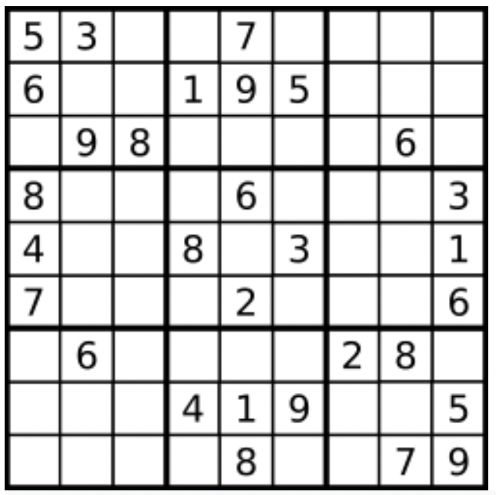

Board = [["5","3",".",".","7",".",".",".","."],["6",".",".","1","9","5",".",".","."],[".","9","8",".",".",".",".","6","."],["8",".",".",".","6",".",".",".","3"],["4",".",".","8",".","3",".",".","1"],["7",".",".",".","2",".",".",".","6"],[".","6",".",".",".",".","2","8","."],[".",".",".","4","1","9",".",".","5"],[".",".",".",".","8",".",".","7","9"]]

**Sample Output**

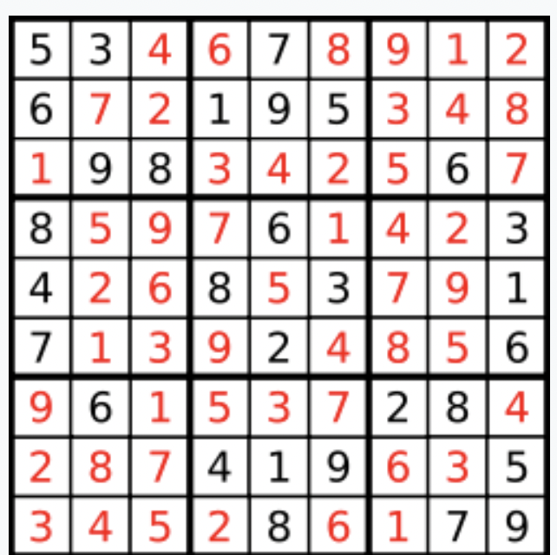

[["5","3","4","6","7","8","9","1","2"],["6","7","2","1","9","5","3","4","8"],["1","9","8","3","4","2","5","6","7"],["8","5","9","7","6","1","4","2","3"],["4","2","6","8","5","3","7","9","1"],["7","1","3","9","2","4","8","5","6"],["9","6","1","5","3","7","2","8","4"],["2","8","7","4","1","9","6","3","5"],["3","4","5","2","8","6","1","7","9"]]

**Code**

1. StartingRow = 3*(row/3) & StartingCol = 3*(col/3)
2. StartingRow = row - row%3 & StartingCol = col - col%3

**Code**

class Solution {

public boolean isSafe(char[][] board, int row, int col, int number) {

//column

for(int i=0; i<board.length; i++) {

if(board[i][col] == (char)(number+'0')) {

return false;

}

}

//row

for(int j=0; j<board.length; j++) {

if(board[row][j] == (char)(number+'0')) {

return false;

}

}

//grid

int sr = 3 * (row/3);

int sc = 3 * (col/3);

for(int i=sr; i<sr+3; i++) {

for(int j=sc; j<sc+3; j++) {

if(board[i][j] == (char)(number+'0')) {

return false;

}

}

}

return true;

}

public boolean helper(char[][] board, int row, int col) {

if(row == board.length) {

return true;

}

int nrow = 0;

int ncol = 0;

if(col == board.length-1) {

nrow = row + 1;

ncol = 0;

} else {

nrow = row;

ncol = col + 1;

}

if(board[row][col] != '.') {

if(helper(board, nrow, ncol)) {

return true;

}

} else {

//fill the place

for(int i=1; i<=9; i++) {

if(isSafe(board, row, col, i)) {

board[row][col] = (char)(i+'0');

if(helper(board, nrow, ncol))

return true;

else

board[row][col] = '.';

}

}

}

return false;

}

public void solveSudoku(char[][] board) {

helper(board, 0, 0);

}

}

**Object Oriented Programming Systems in Java**

**Object-Oriented Programming** is a methodology or paradigm to design a program using classes and objects. It simplifies the software development and maintenance by providing some concepts defined below:

**Class** is a user-defined data type which defines its properties and its functions. Class is the only logical representation of the data. For example, Human being is a class. The body parts of a human being are its properties, and the actions performed by the body parts are known as functions. The class does not occupy any memory space till the time an object is instantiated.

**Object** is a run-time entity. It is an instance of the class. An object can represent a person, place or any other item. An object can operate on both data members and member functions.

Example 1:

class Student {

String name;

int age;

public void getInfo() {

System.out.println("The name of this Student is " + this.name);

System.out.println("The age of this Student is " + this.age);

}

}

public class OOPS {

public static void main(String args[]) {

Student s1 = new Student();

s1.name = "Aman";

s1.age = 24;

s1.getInfo();

Student s2 = new Student();

s2.name = "Shradha";

s2.age = 22;

s2.getInfo();

}

}

Example 2:

class Pen {

String color;

public void printColor() {

System.out.println("The color of this Pen is " + this.color);

}

}

public class OOPS {

public static void main(String args[]) {

Pen p1 = new Pen();

p1.color = blue;

Pen p2 = new Pen();

p2.color = black;

Pen p3 = new Pen();

p3.color = red;

p1.printColor();

p2.printColor();

p3.printColor();

}

}

**Note:** When an object is created **using** a new keyword, then space is allocated for the variable in a heap, and the starting address is stored in the stack memory.

**‘this’ keyword:** ‘this’ keyword in Java that refers to the current instance of the class. In OOPS it is used to:

1. pass the current object as a parameter to another method
2. refer to the current class instance variable

**Constructor:** Constructor is a special method which is invoked automatically at the time of object creation. It is used to initialize the data members of new objects generally.

* Constructors have the same name as class or structure.
* Constructors don’t have a return type. (Not even void)
* Constructors are only called once, at object creation.

There can be **three types** of constructors in Java.

1. Non-Parameterized constructor: A constructor which has no argument is known as non-parameterized constructor (or no-argument constructor). It is invoked at the time of creating an object. If we don’t create one then it is created by default by Java.

class Student {

String name;

int age;

Student() {

System.out.println("Constructor called");

}

}

2. Parameterized constructor: Constructor which has parameters is called a parameterized constructor. It is used to provide

different values to distinct objects.

class Student {

String name;

int age;

Student(String name, int age) {

this.name = name;

this.age = age;

}

}

3. Copy constructor: A Copy constructor is an **overloaded**

constructor used to declare and initialize an object from another object. There is only a user defined copy constructor in Java (C++ has a default one too).

class Student {

String name;

int age;

Student(Student s2) {

this.name = s2.name;

this.age = s2.age;

}

}

**Note:** Unlike languages like C++, Java has no Destructor. Instead, Java has an efficient garbage collector that deallocates memory automatically.

**Polymorphism**

Polymorphism is the ability to present the same interface for differing underlying forms (data types). With polymorphism, each of these classes will have different underlying data. Precisely, Poly means ‘many’ and morphism means ‘forms’.

**Types of Polymorphism IMP**

1. Compile Time Polymorphism (Static)

2. Runtime Polymorphism (Dynamic)

Let’s understand them one by one:

**Compile Time Polymorphism:** The polymorphism which is implemented at the compile time is known as compile-time polymorphism. Example - Method Overloading

Method Overloading: Method overloading is a technique which allows you to have more than one function with the same function name but with different functionality. Method overloading can be possible on the following basis:

1. The type of the parameters passed to the function.

2. The number of parameters passed to the function.

class Student {

String name;

int age;

public void displayInfo(String name) {

System.out.println(name);

}

public void displayInfo(int age) {

System.out.println(age);

}

public void displayInfo(String name, int age) {

System.out.println(name);

System.out.println(age);

}

}

**Runtime Polymorphism:** Runtime polymorphism is also known as **dynamic polymorphism**. Function overriding is an example of runtime polymorphism. Function overriding means when the child class contains the method which is already present in the parent class. Hence, **the child class overrides the method of the parent class**. In case of function overriding, parent and child classes both contain the same function with a different definition. The call to the function is determined at runtime is known as runtime polymorphism.

class Shape {

public void area() {

System.out.println("Displays Area of Shape");

}

}

class Triangle extends Shape {

public void area(int h, int b) {

System.out.println((1/2)*b*h);

}

}

class Circle extends Shape {

public void area(int r) {

System.out.println((3.14)*r*r);

}

}

**Inheritance**

Inheritance is a process in which one object acquires all the properties and behaviours of its parent object automatically. In such a way, you can **reuse, extend or modify** the attributes and behaviours which are defined in other classes.

In Java, the class which inherits the members of another class is called derived class and the class whose members are inherited is called base class. The derived class is the specialized class for the base class.

Types of Inheritance:

1. Single Inheritance: When one class inherits another class, it is known as single level inheritance

class Shape {

public void area() {

System.out.println("Displays Area of Shape");

}

}

class Triangle extends Shape {

public void area(int h, int b) {

System.out.println((1/2)*b*h);

}

}

2. Hierarchical Inheritance: Hierarchical inheritance is defined as the process of deriving more than one class from a base class.

class Shape {

public void area() {

System.out.println("Displays Area of Shape");

}

}

class Triangle extends Shape {

public void area(int h, int b) {

System.out.println((1/2)*b*h);

}

}

class Circle extends Shape {

public void area(int r) {

System.out.println((3.14)*r*r);

}

}

3. Multilevel Inheritance: Multilevel inheritance is a process of deriving a class from another derived class.

class Shape {

public void area() {

System.out.println("Displays Area of Shape");

}

}

class Triangle extends Shape {

public void area(int h, int b) {

System.out.println((1/2)*b*h);

}

}

class EquilateralTriangle extends Triangle {

int side;

}

4. Hybrid Inheritance: Hybrid inheritance is a combination of

simple, multiple inheritance and hierarchical inheritance.

**Package in Java**

Package is a group of similar types of classes, interfaces and sub-packages. Packages can be built-in or user defined.

Built-in packages - java, util, io etc.

import java.util.Scanner;

import java.io.IOException;

**Access Modifiers in Java**

* **Private**: The access level of a private modifier is only within the class. It cannot be accessed from outside the class.
* **Default**: The access level of a default modifier is only within the package. It cannot be accessed from outside the package. If you do not specify any access level, it will be the default.
* **Protected**: The access level of a protected modifier is within the package and outside the package through child class. If you do not make the child class, it cannot be accessed from outside the package.
* **Public**: The access level of a public modifier is everywhere. It can be accessed from within the class, outside the class, within the package and outside the package.

package newpackage;

class Account {

public String name;

protected String email;

private String password;

public void setPassword(String password) {

this.password = password;

}

}

public class Sample {

public static void main(String args[]) {

Account a1 = new Account();

a1.name = "Apna College";

a1.setPassword("abcd");

a1.email = "hello@apnacollege.com";

}

}

**Encapsulation**

Encapsulation is the process of combining data and functions into a single unit called class. In Encapsulation, the data is not accessed directly; it is accessed through the functions present inside the class. In simpler words, attributes of the class are kept private and public getter and setter methods are provided to manipulate these attributes. Thus, encapsulation makes the concept of data hiding possible. (**Data hiding**: a language feature to restrict access to members of an object, reducing the negative effect due to dependencies. e.g. "protected", "private" feature in Java).

**Abstraction**

We try to obtain an **abstract view**, model or structure of a real-life problem, and reduce its unnecessary details. With definition of properties of problems, including the data which are affected and the operations which are identified, the model abstracted from problems can be a standard solution to this type of problems. It is an efficient way since there are nebulous real-life problems that have similar properties.

In simple terms, it is hiding the unnecessary details & showing only the essential parts/functionalities to the user.

Data binding:Data binding is a process of binding the application UI and business logic. Any change made in the business logic will reflect directly to the application UI.

**Abstraction** is achieved in 2 ways:

* Abstract class
* Interfaces (Pure Abstraction)

1. **Abstract Class**

* An abstract class must be declared with an abstract keyword.
* It can have abstract and non-abstract methods.
* It cannot be instantiated.
* It can have constructors and static methods also.
* It can have final methods which will force the subclass not to change the body of the method.

abstract class Animal {

abstract void walk();

void breathe() {

System.out.println("This animal breathes air");

}

Animal() {

System.out.println("You are about to create an Animal.");

}

}

class Horse extends Animal {

Horse() {

System.out.println("Wow, you have created a Horse!");

}

void walk() {

System.out.println("Horse walks on 4 legs");

}

}

class Chicken extends Animal {

Chicken() {

System.out.println("Wow, you have created a Chicken!");

}

void walk() {

System.out.println("Chicken walks on 2 legs");

}

}

public class OOPS {

public static void main(String args[]) {

Horse horse = new Horse();

horse.walk();

horse.breathe();

}

}

2. **Interfaces**

* All the fields in interfaces are public, static and final by default.
* All methods are public & abstract by default.
* A class that implements an interface must implement all the methods declared in the interface.
* Interfaces support the functionality of multiple inheritance.

interface Animal {

void walk();

}

class Horse implements Animal {

public void walk() {

System.out.println("Horse walks on 4 legs");

}

}

class Chicken implements Animal {

public void walk() {

System.out.println("Chicken walks on 2 legs");

}

}

public class OOPS {

public static void main(String args[]) {

Horse horse = new Horse();

horse.walk();

}

}

**Static Keyword**

Static can be:

1. Variable (also known as a class variable)
2. Method (also known as a class method)
3. Block
4. Nested class

class Student {

static String school;

String name;

}

public class OOPS {

public static void main(String args[]) {

Student.school = "JMV";

Student s1 = new Student();

Student s2 = new Student();

s1.name = "Meena";

s2.name = "Beena";

System.out.println(s1.school);

System.out.println(s2.school);

}

}

**ArrayList in Java**

**Operations:**

1. **Declare an ArrayList of different Types**
2. **Add Element**
3. **Get Element**
4. **Add Element at a specific Index**
5. **Set Element at a specific Index**
6. **Delete Element from an Index**
7. **Size of the List**
8. **Loop/Iterate on the List**
9. **Sort the List**

**import java.util.ArrayList;**

**import java.util.Collections;**

**class ArrayLists {**

**public static void main(String args[]) {**

**ArrayList<Integer> list = new ArrayList<Integer>();**

**ArrayList<String> list2 = new ArrayList<String>();**

**ArrayList<Boolean> list3 = new ArrayList<Boolean>();**

**//add elements**

**list.add(1);**

**list.add(3);**

**list.add(4);**

**list.add(5);**

**System.out.println(list);**

**//to get an element**

**int element = list.get(0); // 0 is the index**

**System.out.println(element);**

**//add element in between**

**list.add(1,2); // 1 is the index and 2 is the element to be added**

**System.out.println(list);**

**//set element**

**list.set(0,0);**

**System.out.println(list);**

**//delete elements**

**list.remove(0); // 0 is the index**

**System.out.println(list);**

**//size of list**

**int size = list.size();**

**System.out.println(size);**

**//Loops on lists**

**for(int i=0; i<list.size(); i++) {**

**System.out.print(list.get(i) + " ");**

**}**

**System.out.println();**

**//Sorting the list**

**list.add(0);**

**Collections.sort(list);**

**System.out.println(list);**

**}**

**}**

**Homework Problems**

Try solving all problems of arrays with ArrayList.

# JAVA Collection Framework

**Iterable**

Collection

List

Queue

Set

# JAVA Methods on Collections

add

size

remove

iterate

addAll

removeAll

clear

**JAVA List Interface**

List

**ArrayList**

**LinkedList**

**Vector**

**Stack**

**JAVA Queue Interface (FIFO)**

Queue

PriorityQueue

LinkedList

Deque

ArrayDeque

**JAVA Map Interface**

**JAVA Map Interface**

Map

HashMap

LinkedHashMap

SortedMap

Hashtable

TreeMap

Set

HashSet

LinkedHashSet

SortedSet

TreeSet

**Introduction to Linked List**

**Java**

**Linked List**

**LinkedList class Implementation (Collection Framework)**

**import java.util.*;**

**class LL {**

**public static void main(String args[]) {**

**LinkedList<String> list = new LinkedList<String>();**

**list.add("is");**

**list.add("a");**

**list.addLast("list");**

**list.addFirst("this");**

**list.add(3, "linked");**

**System.out.println(list);**

**System.out.println(list.get(0));**

**System.out.println(list.size());**

**list.remove(3);**

**list.removeFirst();**

**list.removeLast();**

**System.out.println(list);**

**}**

**}**

**Scratch Implementation (Important for BEGINNERS)**

**class LL {**

**Node head;**

**private int size;**

**LL () {**

**size = 0;**

**}**

**public class Node {**

**String data;**

**Node next;**

**Node(String data) {**

**this.data = data;**

**this.next = null;**

**size++;**

**}**

**}**

**public void addFirst(String data) {**

**Node newNode = new Node(data);**

**newNode.next = head;**

**head = newNode;**

**}**

**public void addLast(String data) {**

**Node newNode = new Node(data);**

**if(head == null) {**

**head = newNode;**

**return;**

**}**

**Node lastNode = head;**

**while(lastNode.next != null) {**

**lastNode = lastNode.next;**

**}**

**lastNode.next = newNode;**

**}**

**public void printList() {**

**Node currNode = head;**

**while(currNode != null) {**

**System.out.print(currNode.data+" -> ");**

**currNode = currNode.next;**

**}**

**System.out.println("null");**

**}**

**public void removeFirst() {**

**if(head == null) {**

**System.out.println("Empty List, nothing to delete");**

**return;**

**}**

**head = this.head.next;**

**size--;**

**}**

**public void removeLast() {**

**if(head == null) {**

**System.out.println("Empty List, nothing to delete");**

**return;**

**}**

**size--;**

**if(head.next == null) {**

**head = null;**

**return;**

**}**

**Node currNode = head;**

**Node lastNode = head.next;**

**while(lastNode.next != null) {**

**currNode = currNode.next;**

**lastNode = lastNode.next;**

**}**

**currNode.next = null;**

**}**

**public int getSize() {**

**return size;**

**}**

**public static void main(String args[]) {**

**LL list = new LL();**

**list.addLast("is");**

**list.addLast("a");**

**list.addLast("list");**

**list.printList();**

**list.addFirst("this");**

**list.printList();**

**System.out.println(list.getSize());**

**list.removeFirst();**

**list.printList();**

**list.removeLast();**

**list.printList();**

**}**

**}**

**How to insert in the middle of a Linked List (at a specified index ‘i’) ?**

**Scratch**

**public void addInMiddle(int index, String data) {**

**if(index > size || index < 0) {**

**System.out.println("Invalid Index value");**

**return;**

**}**

**size++;**

**Node newNode = new Node(data);**

**if(head == null || index == 0) {**

**newNode.next = head;**

**head = newNode;**

**return;**

**}**

**Node currNode = head;**

**for(int i=1; i<size; i++) {**

**if(i == index) {**

**Node nextNode = currNode.next;**

**currNode.next = newNode;**

**newNode.next = nextNode;**

**break;**

**}**

**currNode = currNode.next;**

**}**

**}**

**LinkedList class**

**import java.util.*;**

**class LL {**

**public static void main(String args[]) {**

**LinkedList<String> list = new LinkedList<String>();**

**list.addFirst("shradha");**

**list.addFirst("name");**

**list.addFirst("my");**

**System.out.println(list);**

**list.add(2, "is");**

**System.out.println(list);**

**}**

**}**

**Homework Problems**

1. Make a Linked List & add the following elements to it: (1, 5, 7, 3, 8, 2, 3). Search for the number 7 & display its index.
2. Take elements (numbers in the range of 1-50) of a Linked List as input from the user. Delete all nodes which have values greater than 25.

**Reverse a Linked List**

**Java**

Reverse a Linked List without using extra space.

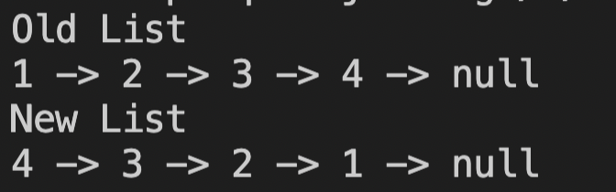

**Iterative Method**

Time complexity - O(n)

Space complexity - O(1)

**public void reverseList() {**

**if(head == null || head.next == null) {**

**return;**

**}**

**Node prevNode = head;**

**Node currNode = head.next;**

**while(currNode != null) {**

**Node nextNode = currNode.next;**

**currNode.next = prevNode;**

**prevNode = currNode;**

**currNode = nextNode;**

**}**

**head.next = null;**

**head = prevNode;**

**}**

**Recursive Method**

Time complexity - O(n)

Space complexity - O(1)

public Node reverseListRecursive(Node head) {

//empty node || last node or only one node

if(head == null || head.next == null) {

return head;

}

Node newHead = reverseListRecursive(head.next);

head.next.next = head;

head.next = null;

return newHead;

}

**Collections Method**

Time complexity - O(n)

Space complexity - O(1)

**LinkedList<Integer> list2 = new LinkedList<>();**

**list2.add(1);**

**list2.add(2);**

**Collections.reverse(list2);**

**Homework Problems**

1. <https://leetcode.com/problems/swap-nodes-in-pairs/>
2. <https://leetcode.com/problems/remove-nth-node-from-end-of-list/>
3. <https://leetcode.com/problems/reverse-linked-list-ii/>
4. <https://leetcode.com/problems/remove-nth-node-from-end-of-list/>

**BEST Linked List Questions**

**Java**

1. **Find the nth node from the end & remove it.**

Time complexity - O(n)

Space complexity - O(1)

public ListNode removeNthFromEnd(ListNode head, int n) {

if(head.next == null) {

return null;

}

int size = 0;

ListNode temp = head;

while(temp != null) {

temp = temp.next;

size++;

}

//removing SIZEth node from last i.e. head

if(n == size) {

return head.next;

}

//find previous node

int ptf = size - n; // position to find

ListNode prev = head; // previous node

int cp = 1; // current position

while(cp != ptf) {

prev = prev.next;

cp++;

}

prev.next = prev.next.next;

return head;

}

1. **Check if a Linked List is a palindrome**

Time complexity - O(n)

Space complexity - O(1)

public ListNode getMiddle(ListNode head) {

ListNode fast = head;

ListNode slow = head;

while (fast.next != null && fast.next.next != null) {

fast = fast.next.next;

slow = slow.next;

}

return slow;

}

public ListNode reverse(ListNode head) {

ListNode prev = null;

ListNode curr = head;

while (curr != null) {

ListNode next = curr.next;

curr.next = prev;

prev = curr;

curr = next;

}

return prev;

}

public boolean isPalindrome(ListNode head) {

if(head == null || head.next == null) {

return true;

}

ListNode firstHalfEnd = getMiddle(head);

ListNode secondHalfStart = reverse(firstHalfEnd.next);

ListNode firstHalfStart = head;

while(secondHalfStart != null) {

if(secondHalfStart.val != firstHalfStart.val) {

return false;

}

secondHalfStart = secondHalfStart.next;

firstHalfStart = firstHalfStart.next;

}

return true;

}

1. **Detecting Loop in a Linked List.**

Time complexity - O(n)

Space complexity - O(1)

public boolean hasCycle(ListNode head) {

ListNode slow = head;

ListNode fast = head;

while(fast != null && fast.next != null) {

slow = slow.next;

fast = fast.next.next;

if(fast == slow) {

return true;

}

}

return false;

}

**Homework Problems**

1. Removing Loops in a Linked List.

(Please try on your own first. The answer will be updated soon!)

**Queue**

* **Queue using Array**

//queue using array

public class QueueB {

static class Queue {

static int arr[];

static int size;

static int rear;

Queue(int size) {

this.size = size;

arr = new int[size];

rear = -1;

}

public static boolean isEmpty() {

return rear == -1;

}

public static boolean isFull() {

return rear == size-1;

}

public static void add(int data) {

if(isFull()) {

System.out.println("Overflow");

return;

}

arr[++rear] = data;

}

//O(n)

public static int remove() {

if(isEmpty()) {

System.out.println("empty queue");

return -1;

}

int front = arr[0];

for(int i=0; i<rear; i++) {

arr[i] = arr[i+1];

}

rear–;

return front;

}

public static int peek() {

if(isEmpty()) {

System.out.println("empty queue");

return -1;

}

return arr[0];

}

}

public static void main(String args[]) {

Queue q = new Queue(5);

q.add(1);

q.add(2);

q.add(3);

System.out.println(q.remove());

System.out.println(q.peek());

}

}

**Circular queue using array**

//circular queue using array

public class QueueB {

static class Queue {

static int arr[];

static int size;

static int front = -1;

static int rear = -1;

Queue(int size) {

this.size = size;

arr = new int[size];

}

public static boolean isEmpty() {

return rear == -1 && front == -1;

}

public static boolean isFull() {

return (rear+1)%size == front;

}

public static void add(int data) {

if(isFull()) {

System.out.println("Overflow");

return;

}

//if it's the 1st element

if(front == -1) {

front = 0;

}

rear = (rear + 1)%size;

arr[rear] = data;

}

public static int remove() {

if(isEmpty()) {

System.out.println("empty queue");

return -1;

}

int res = arr[front];

//if only 1 element is present

if(front == rear) {

front = rear = -1;

} else {

front = (front+1)%size;

}

return res;

}

public static int peek() {

if(isEmpty()) {

System.out.println("empty queue");

return -1;

}

return arr[front];

}

}

public static void main(String args[]) {

Queue q = new Queue(5);

q.add(1);

q.add(2);

q.add(3);

q.add(4);

q.add(5);

System.out.println(q.remove());

q.add(6);

System.out.println(q.remove());

q.add(7);

while(!q.isEmpty()) {

System.out.println(q.remove());

}

}

}

* **Queue using Linked List**

//queue using Linked List

public class QueueB {

static class Node {

int data;

Node next;

Node(int data) {

this.data = data;

next = null;

}

}

static class Queue {

static Node head = null;

static Node tail = null;

public static boolean isEmpty() {

return head == null && tail == null;

}

public static void add(int data) {

Node newNode = new Node(data);

if(isEmpty()) {

tail = head = newNode;

} else {

tail.next = newNode;

tail = newNode;

}

}

public static int remove() {

if(isEmpty()) {

System.out.println("empty queue");

return -1;

}

int front = head.data;

//single node

if(head == tail) {

tail = null;

}

head = head.next;

return front;

}

public static int peek() {

if(isEmpty()) {

System.out.println("empty queue");

return -1;

}

return head.data;

}

}

public static void main(String args[]) {

Queue q = new Queue();

q.add(1);

q.add(2);

q.add(3);

q.add(4);

q.add(5);

while(!q.isEmpty()) {

System.out.println(q.peek());

q.remove();

}

}

}

* **Java Collection Framework**

//queue using Java Collection Framework

import java.util.*;

public class QueueB {

public static void main(String args[]) {

//Queue<Integer> q = new LinkedList();

Queue<Integer> q = new ArrayDeque();

q.add(1);

q.add(2);

q.add(3);

q.add(4);

q.add(5);

while(!q.isEmpty()) {

System.out.println(q.peek());

q.remove();

}

}

}

* **Queue using 2 stacks**

//queue using 2 stacks

import java.util.*;

public class QueueB {

static class Queue {

static Stack<Integer> s1 = new Stack<>();

static Stack<Integer> s2 = new Stack<>();

public static boolean isEmpty() {

return s1.isEmpty();

}

public static void add(int data) {

while(!s1.isEmpty()) {

s2.push(s1.pop());

}

s1.push(data);

while(!s2.isEmpty()) {

s1.push(s2.pop());

}

}

public static int remove() {

return s1.pop();

}

public static int peek() {

return s1.peek();

}

}

public static void main(String args[]) {

Queue q = new Queue();

q.add(1);

q.add(2);

q.add(3);

while(!q.isEmpty()) {

System.out.println(q.peek());

q.remove();

}

}

}

**Trees**

1. **Build Tree from given Preorder Sequence**

//Build a Tree from its Preorder traversal

public class BinaryTreesYT {

static class Node {

int data;

Node left;

Node right;

Node(int data) {

this.data = data;

this.left = null;

this.right = null;

}

}

static class BinaryTree {

static int idx = -1;

public static Node buildTree(int nodes[]) {

idx++;

if(nodes[idx] == -1) {

return null;

}

Node newNode = new Node(nodes[idx]);

newNode.left = buildTree(nodes);

newNode.right = buildTree(nodes);

return newNode;

}

}

public static void main(String args[]) {

int nodes[] = {1, 2, 4, -1, -1, 5, -1, -1, 3, -1, 6, -1, -1};

BinaryTree tree = new BinaryTree();

Node root = tree.buildTree(nodes);

System.out.println(root.data);

}

}

1. **Tree Traversals**
2. Preorder

public static void preorder(Node root) {

if(root == null) {

System.out.print(-1+" ");

return;

}

System.out.print(root.data+" ");

preorder(root.left);

preorder(root.right);

}

1. Inorder

public static void inorder(Node root) {

if(root == null) {

System.out.print(-1+" ");

return;

}

inorder(root.left);

System.out.print(root.data+" ");

inorder(root.right);

}

1. Postorder

public static void postorder(Node root) {

if(root == null) {

System.out.print(-1+" ");

return;

}

postorder(root.left);

postorder(root.right);

System.out.print(root.data+" ");

}

1. Level Order

public static void levelOrder(Node root) {

if(root == null) {

return;

}

Queue<Node> q = new LinkedList<>();

q.add(root);

q.add(null);

while(!q.isEmpty()) {

Node curr = q.remove();

if(curr == null) {

System.out.println();

//queue empty

if(q.isEmpty()) {

break;

} else {

q.add(null);

}

} else {

System.out.print(curr.data+" ");

if(curr.left != null) {

q.add(curr.left);

}

if(curr.right != null) {

q.add(curr.right);

}

}

}

}

**3. Height of Tree**

public static int height(Node root) {

if(root == null) {

return 0;

}

int leftHeight = height(root.left);

int rightHeight = height(root.right);

return Math.max(leftHeight, rightHeight) + 1;

}

**4. Count of Nodes of Tree**

public static int countOfNodes(Node root) {

if(root == null) {

return 0;

}

int leftNodes = countOfNodes(root.left);

int rightNodes = countOfNodes(root.right);

return leftNodes + rightNodes + 1;

}

**5. Sum of Nodes of Tree**

public static int sumOfNodes(Node root) {

if(root == null) {

return 0;

}

int leftSum = sumOfNodes(root.left);

int rightSum = sumOfNodes(root.right);

return leftSum + rightSum + root.data;

}

**6. Diameter of Tree - Approach1 O(N^2)**

public static int diameter(Node root) {

if(root == null) {

return 0;

}

int diam1 = height(root.left) + height(root.right) + 1;

int diam2 = diameter(root.left);

int diam3 = diameter(root.right);

return Math.max(diam1, Math.max(diam2, diam3));

}

**7. Diameter of Tree - Approach2 O(N)**

public static TreeInfo diameter(Node root) {

if(root == null) {

return new TreeInfo(0, 0);

}

TreeInfo leftTI = diameter(root.left);

TreeInfo rightTI = diameter(root.right);

int myHeight = Math.max(leftTI.height, rightTI.height) + 1;

int diam1 = leftTI.height + rightTI.height + 1;

int diam2 = leftTI.diam;

int diam3 = rightTI.diam;

int myDiam = Math.max(diam1, Math.max(diam2, diam3));

return new TreeInfo(myHeight, myDiam);

}

**8. Subtree of another tree**

public boolean isIdentical(TreeNode root,TreeNode subRoot){

if(subRoot == null && root == null){

return true;

}

if(root == null || subRoot == null){

return false;

}

if(root.val == subRoot.val){

return isIdentical(root.left, subRoot.left) && isIdentical(root.right, subRoot.right);

}

return false;

}

public boolean isSubtree(TreeNode root, TreeNode subRoot) {

if(subRoot == null){

return true;

}

if(root == null){

return false;

}

if(isIdentical(root, subRoot)){

return true;

}

return isSubtree(root.left, subRoot) || isSubtree(root.right, subRoot);

}

**HashSet in Java**

import java.util.HashSet;

import java.util.Iterator;

public class Hashing {

public static void main(String args[]) {

HashSet<Integer> set = new HashSet<>();

//Add

set.add(1);

set.add(2);

set.add(3);

set.add(1);

//Size

System.out.println("size of set is : " + set.size());

//Search

if(set.contains(1)) {

System.out.println("present");

}

if(!set.contains(6)) {

System.out.println("absent");

}

//Delete

set.remove(1);

if(!set.contains(1)) {

System.out.println("absent");

}

//Print all elements

System.out.println(set);

//Iteration - HashSet does not have an order

set.add(0);

Iterator it = set.iterator();

while (it.hasNext()) {

System.out.print(it.next() + ", ");

}

System.out.println();

//isEmpty

if(!set.isEmpty()) {

System.out.println("set is not empty");

}

}

}

**HashMap in Java**

import java.util.*;

public class Hashing {

public static void main(String args[]) {

//Creation

HashMap<String, Integer> map = new HashMap<>();

//Insertion

map.put("India", 120);

map.put("US", 30);

map.put("China", 150);

System.out.println(map);

map.put("China", 180);

System.out.println(map);

//Searching

if(map.containsKey("Indonesia")) {

System.out.println("key is present in the map");

} else {

System.out.println("key is not present in the map");

}

System.out.println(map.get("China")); //key exists

System.out.println(map.get("Indonesia")); //key doesn't exist

//Iteration (1)

for( Map.Entry<String, Integer> e : map.entrySet()) {

System.out.println(e.getKey());

System.out.println(e.getValue());

}

//Iteration (2)

Set<String> keys = map.keySet();

for(String key : keys) {

System.out.println(key+ " " + map.get(key));

}

//Removing

map.remove("China");

System.out.println(map);

}

}

**Hashmap Implementation**

Java Code

import java.util.*;

public class HashMapCode {

static class HashMap<K,V> { //generics

private class Node {

K key;

V value;

public Node(K key, V value) {

this.key = key;

this.value = value;

}

}

private int n; //n - nodes

private int N; //N - buckets

private LinkedList<Node> buckets[]; //N = buckets.length

@SuppressWarnings("unchecked")

public HashMap() {

this.N = 4;

this.buckets = new LinkedList[4];

for(int i=0; i<4; i++) {

this.buckets[i] = new LinkedList<>();

}

}

private int hashFunction(K key) {

int bi = key.hashCode();

return Math.abs(bi) % N;

}

private int searchInLL(K key, int bi) {

LinkedList<Node> ll = buckets[bi];

for(int i=0; i<ll.size(); i++) {

if(ll.get(i).key == key) {

return i; //di

}

}

return -1;

}

@SuppressWarnings("unchecked")

private void rehash() {

LinkedList<Node> oldBucket[] = buckets;

buckets = new LinkedList[N*2];

for(int i=0; i<N*2; i++) {

buckets[i] = new LinkedList<>();

}

for(int i=0; i<oldBucket.length; i++) {

LinkedList<Node> ll = oldBucket[i];

for(int j=0; j<ll.size(); j++) {

Node node = ll.get(j);

put(node.key, node.value);

}

}

}

public void put(K key, V value) {

int bi = hashFunction(key);

int di = searchInLL(key, bi); //di = -1

if(di == -1) { //key doesn't exist

buckets[bi].add(new Node(key, value));

n++;

} else { //key exists

Node node = buckets[bi].get(di);

node.value = value;

}

double lambda = (double)n/N;

if(lambda > 2.0) {

rehash();

}

}

public boolean containsKey(K key) {

int bi = hashFunction(key);

int di = searchInLL(key, bi); //di = -1

if(di == -1) { //key doesn't exist

return false;

} else { //key exists

return true;

}

}

public V remove(K key) {

int bi = hashFunction(key);

int di = searchInLL(key, bi); //di = -1

if(di == -1) { //key doesn't exist

return null;

} else { //key exists

Node node = buckets[bi].remove(di);

n--;

return node.value;

}

}

public V get(K key) {

int bi = hashFunction(key);

int di = searchInLL(key, bi); //di = -1

if(di == -1) { //key doesn't exist

return null;

} else { //key exists

Node node = buckets[bi].get(di);

return node.value;

}

}

public ArrayList<K> keySet() {

ArrayList<K> keys = new ArrayList<>();

for(int i=0; i<buckets.length; i++) { //bi

LinkedList<Node> ll = buckets[i];

for(int j=0; j<ll.size(); j++) { //di

Node node = ll.get(j);

keys.add(node.key);

}

}

return keys;

}

public boolean isEmpty() {

return n == 0;

}

}

public static void main(String args[]) {

HashMap<String, Integer> map = new HashMap<>();

map.put("India", 190);

map.put("China", 200);

map.put("US", 50);

ArrayList<String> keys = map.keySet();

for(int i=0; i<keys.size(); i++) {

System.out.println(keys.get(i)+" "+map.get(keys.get(i)));

}

map.remove("India");

System.out.println(map.get("India"));

}

}

**Tries**

**Java Code**

**Trie : Implementations, Insert & Search**

public class Tries {

static class Node {

Node[] children = new Node[26];

boolean eow;

public Node() {

for (int i=0; i<26; i++) {

children[i] = null;

}

}

}

public static Node root = new Node();

public static void insert(String word) { //O(n)

int level = 0;

int len = word.length();

int idx = 0;

Node curr = root;

for(; level<len; level++) {

idx = word.charAt(level)-'a';

if(curr.children[idx] == null) {

curr.children[idx] = new Node();

}

curr = curr.children[idx];

}

curr.eow = true;

}

public static boolean search(String key) { //O(n)

int level = 0;

int len = key.length();

int idx = 0;

Node curr = root;

for(; level<len; level++) {

idx = key.charAt(level)-'a';

if(curr.children[idx] == null) {

return false;

}

curr = curr.children[idx];

}

return curr.eow == true;

}

public static void main(String args[]) {

String words[] = {"the", "a", "there", "their", "any", "thee"};

for (String word : words) {

insert(word);

System.out.println("inserted " + word);

}

System.out.println("thee -> " + search("thee"));

System.out.println("thor -> " + search("thor"));

System.out.println(startsWith("the"));

System.out.println(startsWith("thi"));

}

}

**Question 1**

public static boolean wordBreak(String key) {

int len = key.length();

if(len == 0) {

return true;

}

for(int i=1; i<=len; i++) {

if( search(key.substring(0, i)) &&

wordBreak(key.substring(i)) ) {

return true;

}

}

return false;

}

**Question 2**

public static boolean startsWith(String prefix) {

Node curr = root;

for(int i=0; i<prefix.length(); i++) {

int idx = prefix.charAt(i)-'a';

if(curr.children[idx] == null) {

return false;

}

curr = curr.children[idx];

}

return true;

}

**Question 3**

public static void longestWord(Node root, StringBuilder curr) {

for(int i=0; i<26; i++) {

if(root.children[i] != null && root.children[i].eow == true) {

curr.append((char)(i+'a'));

if(curr.length() > ans.length()) {

ans = curr.toString();

}

longestWord(root.children[i], curr);

curr.deleteCharAt(curr.length()-1);

}

}

}

public static String ans = "";

**Question 4**

public static void buildTrie(String str) {

//insert all suffixes to Trie

root = new Node();

for(int i=0; i<str.length(); i++) {

insert(str.substring(i));

}

}

public static int countNodes(Node root) {

if(root == null) {

return 0;

}

int count = 0;

for(int i=0; i<26; i++) {

if(root.children[i] != null) {

count+= countNodes(root.children[i]);

}

}

return 1+count; //extra one for the self node

}

**Graph Data Structure**

Graph Codes

Part1

BFS

import java.util.*;

public class BFS {

static class Edge {

int src;

int dest;

int wt;

public Edge(int s, int d, int w) {

this.src = s;

this.dest = d;

this.wt = w;

}

}

static void createGraph(ArrayList<Edge> graph[]) {

for(int i=0; i<graph.length; i++) {

graph[i] = new ArrayList<>();

}

graph[0].add(new Edge(0, 1, 1));

graph[0].add(new Edge(0, 2, 1));

graph[1].add(new Edge(1, 0, 1));

graph[1].add(new Edge(1, 3, 1));

graph[2].add(new Edge(2, 0, 1));

graph[2].add(new Edge(2, 4, 1));

graph[3].add(new Edge(3, 1, 1));

graph[3].add(new Edge(3, 4, 1));

graph[3].add(new Edge(3, 5, 1));

graph[4].add(new Edge(4, 2, 1));

graph[4].add(new Edge(4, 3, 1));

graph[4].add(new Edge(4, 5, 1));

graph[5].add(new Edge(5, 3, 1));

graph[5].add(new Edge(5, 4, 1));

graph[5].add(new Edge(5, 6, 1));

graph[5].add(new Edge(6, 5, 1));

}

public static void bfs(ArrayList<Edge> graph[], int V) {

boolean visited[] = new boolean[V];

Queue<Integer> q = new LinkedList<>();

q.add(0); //Source = 0

while(!q.isEmpty()) {

int curr = q.remove();

if(!visited[curr]) {

System.out.print(curr+" ");

visited[curr] = true;

for(int i=0; i<graph[curr].size(); i++) {

Edge e = graph[curr].get(i);

q.add(e.dest);

}

}

}

System.out.println();

}

public static void main(String args[]) {

/*

1 --- 3

/ | \

0 | 5 -- 6

\ | /

2 ---- 4

*/

int V = 7;

ArrayList<Edge> graph[] = new ArrayList[V];

createGraph(graph);

bfs(graph, V);

}

}

DFS

import java.util.*;

public class DFS {

static class Edge {

int src;

int dest;

int wt;

public Edge(int s, int d, int w) {

this.src = s;

this.dest = d;

this.wt = w;

}

}

static void createGraph(ArrayList<Edge> graph[]) {

for(int i=0; i<graph.length; i++) {

graph[i] = new ArrayList<>();

}

graph[0].add(new Edge(0, 1, 1));

graph[0].add(new Edge(0, 2, 1));

graph[1].add(new Edge(1, 0, 1));

graph[1].add(new Edge(1, 3, 1));

graph[2].add(new Edge(2, 0, 1));

graph[2].add(new Edge(2, 4, 1));

graph[3].add(new Edge(3, 1, 1));

graph[3].add(new Edge(3, 4, 1));

graph[3].add(new Edge(3, 5, 1));

graph[4].add(new Edge(4, 2, 1));

graph[4].add(new Edge(4, 3, 1));

graph[4].add(new Edge(4, 5, 1));

graph[5].add(new Edge(5, 3, 1));

graph[5].add(new Edge(5, 4, 1));

graph[5].add(new Edge(5, 6, 1));

graph[5].add(new Edge(6, 5, 1));

}

public static void dfs(ArrayList<Edge> graph[], int curr, boolean visited[]) {

if(visited[curr]) {

return;

}

System.out.print(curr+" ");

visited[curr] = true;

for(int i=0; i<graph[curr].size(); i++) {

Edge e = graph[curr].get(i);

dfs(graph, e.dest, visited);

}

}

public static void main(String args[]) {

/*

1 --- 3

/ | \

0 | 5 -- 6

\ | /

2 ---- 4

*/

int V = 7;

ArrayList<Edge> graph[] = new ArrayList[V];

createGraph(graph);

dfs(graph, 0, new boolean[V]);

}

}

All Paths

import java.util.*;

//For Youtube Lecture

public class PrintAllPaths {

static class Edge {

int src;

int dest;

public Edge(int s, int d) {

this.src = s;

this.dest = d;

}

}

static void createGraph(ArrayList<Edge> graph[]) {

for(int i=0; i<graph.length; i++) {

graph[i] = new ArrayList<>();

}

graph[0].add(new Edge(0, 1));

graph[0].add(new Edge(0, 2));

graph[1].add(new Edge(1, 0));

graph[1].add(new Edge(1, 3));

graph[2].add(new Edge(2, 0));

graph[2].add(new Edge(2, 4));

graph[3].add(new Edge(3, 1));

graph[3].add(new Edge(3, 4));

graph[3].add(new Edge(3, 5));

graph[4].add(new Edge(4, 2));

graph[4].add(new Edge(4, 3));

graph[4].add(new Edge(4, 5));

graph[5].add(new Edge(5, 3));

graph[5].add(new Edge(5, 4));

graph[5].add(new Edge(5, 6));

graph[6].add(new Edge(6, 5));

}

public static void printAllPaths(ArrayList<Edge> graph[], int src, int tar, String

path, boolean vis[]) {

if(src == tar) {

System.out.println(path);

return;

}

for(int i=0; i<graph[src].size(); i++) {

Edge e = graph[src].get(i);

if(!vis[e.dest]) {

vis[e.dest] = true;

printAllPaths(graph, e.dest, tar, path+"->"+e.dest, vis);

vis[e.dest] = false;

}

}

}

public static void main(String args[]) {

int V = 7;

ArrayList<Edge> graph[] = new ArrayList[V];

createGraph(graph);

int src = 0;

int tar = 5;

boolean vis[] = new boolean[V];

vis[src] = true;

printAllPaths(graph, src, tar, ""+src, vis);

}

}

Part2

Cycle Detection (Undirected Graph)

import java.util.*;

public class CycleUndirected {

static class Edge {

int src;

int dest;

public Edge(int s, int d) {

this.src = s;

this.dest = d;

}

}

static void createGraph(ArrayList<Edge> graph[]) {

for(int i=0; i<graph.length; i++) {

graph[i] = new ArrayList<>();

}

graph[0].add(new Edge(0, 1));

graph[0].add(new Edge(0, 2));

graph[0].add(new Edge(0, 3));

graph[1].add(new Edge(1, 0));

graph[1].add(new Edge(1, 2));

graph[2].add(new Edge(2, 0));

graph[2].add(new Edge(2, 1));

graph[3].add(new Edge(3, 0));

graph[3].add(new Edge(3, 4));

graph[4].add(new Edge(4, 3));

}

public static boolean isCyclicUtil(ArrayList<Edge>[] graph, boolean vis[], int

curr, int par) {

vis[curr] = true;

for(int i=0; i<graph[curr].size(); i++) {

Edge e = graph[curr].get(i);

//case1

if(vis[e.dest] && e.dest != par) {

boolean isCycle = isCyclicUtil(graph, vis, e.dest, curr);

if(isCycle)

return true;

} else if(e.dest == par) {

//case 2

continue;

} else {

//case 3

return true;

}

}

return false;

}

//O(V+E)

public static boolean isCyclic(ArrayList<Edge>[] graph, boolean vis[]) {

for(int i=0; i<graph.length; i++) {

if(isCyclicUtil(graph, vis, i, -1)) {

return true;

}

}

return false;

}

public static void main(String args[]) {

/*

0 ------- 3

/| |

/ | |

1 | 4

\ |

\ |

2

*/

int V = 5;

ArrayList<Edge> graph[] = new ArrayList[V];

createGraph(graph);

System.out.println(isCyclic(graph, new boolean[V]));

}

}

Cycle Detection (Directed Graph)

import java.util.*;

public class CycleDirected {

static class Edge {

int src;

int dest;

public Edge(int s, int d) {

this.src = s;

this.dest = d;

}

}

//graph1 - true

static void createGraph(ArrayList<Edge> graph[]) {

for(int i=0; i<graph.length; i++) {

graph[i] = new ArrayList<>();

}

graph[0].add(new Edge(0, 2));

graph[1].add(new Edge(1, 0));

graph[2].add(new Edge(2, 3));

graph[3].add(new Edge(3, 0));

}

//graph2 - false

// static void createGraph(ArrayList<Edge> graph[]) {

// for(int i=0; i<graph.length; i++) {

// graph[i] = new ArrayList<>();

// }

// graph[0].add(new Edge(0, 1));

// graph[0].add(new Edge(0, 2));

// graph[1].add(new Edge(1, 3));

// graph[2].add(new Edge(2, 3));

// }

public static boolean isCyclicUtil(ArrayList<Edge>[] graph, int curr, boolean

vis[], boolean stack[]) {

vis[curr] = true;

stack[curr] = true;

for(int i=0; i<graph[curr].size(); i++) {

Edge e = graph[curr].get(i);

if(stack[e.dest]) { //cycle exists

return true;

} else if(!vis[e.dest] && isCyclicUtil(graph, e.dest, vis, stack)) {

return true;

}

}

stack[curr] = false;

return false;

}

//O(V + E)

public static boolean isCyclic(ArrayList<Edge>[] graph) {

boolean vis[] = new boolean[graph.length];

for(int i=0; i<graph.length; i++) {

if(vis[i] == false) {

boolean cycle = isCyclicUtil(graph, i, vis, new boolean[vis.length]);

if(cycle) {

return true;

}

}

}

return false;

}

public static void main(String args[]) {

int V = 4;

ArrayList<Edge> graph[] = new ArrayList[V];

createGraph(graph);

System.out.println(isCyclic(graph));

}

}

Topological Sorting

import java.util.*;

public class TopologicalSort {

static class Edge {

int src;

int dest;

public Edge(int s, int d) {

this.src = s;

this.dest = d;

}

}

static void createGraph(ArrayList<Edge> graph[]) {

for(int i=0; i<graph.length; i++) {

graph[i] = new ArrayList<>();

}

graph[2].add(new Edge(2, 3));

graph[3].add(new Edge(3, 1));

graph[4].add(new Edge(4, 0));

graph[4].add(new Edge(4, 1));

graph[5].add(new Edge(5, 0));

graph[5].add(new Edge(5, 2));

}

public static void topoSortUtil(ArrayList<Edge> graph[], int curr, boolean vis[],

Stack<Integer> s) {

vis[curr] = true;

for(int i=0; i<graph[curr].size(); i++) {

Edge e = graph[curr].get(i);

if(!vis[e.dest]) {

topoSortUtil(graph, e.dest, vis, s);

}

}

s.push(curr);

}

//O(V+E)

public static void topoSort(ArrayList<Edge> graph[]) {

boolean vis[] = new boolean[graph.length];

Stack<Integer> s = new Stack<>();

for(int i=0; i<graph.length; i++) {

if(!vis[i]) {

topoSortUtil(graph, i, vis, s);

}

}

while(!s.isEmpty()) {

System.out.print(s.pop()+" ");

}

}

public static void main(String args[]) {

int V = 6;

ArrayList<Edge> graph[] = new ArrayList[V];

createGraph(graph);

topoSort(graph);

}

}

Part3

Dijkstra’s Algorithm (Shortest Distance)

import java.security.Permissions;

import java.util.*;

public class Dijkstras {

static class Edge {

int src;

int dest;

int wt;

public Edge(int s, int d, int w) {

this.src = s;

this.dest = d;

this.wt = w;

}

}

static void createGraph(ArrayList<Edge> graph[]) {

for(int i=0; i<graph.length; i++) {

graph[i] = new ArrayList<>();

}

graph[0].add(new Edge(0, 1, 2));

graph[0].add(new Edge(0, 2, 4));

graph[1].add(new Edge(1, 3, 7));

graph[1].add(new Edge(1, 2, 1));

graph[2].add(new Edge(2, 4, 3));

graph[3].add(new Edge(3, 5, 1));

graph[4].add(new Edge(4, 3, 2));

graph[4].add(new Edge(4, 5, 5));

}

static class Pair implements Comparable<Pair> {

int n;

int path;

public Pair(int n, int path) {

this.n = n;

this.path = path;

}

@Override

public int compareTo(Pair p2) {

return this.path - p2.path;

}

}

public static int[] dijkstra(ArrayList<Edge> graph[], int src) {

PriorityQueue<Pair> pq = new PriorityQueue<>();

int dist[] = new int[graph.length];

boolean vis[] = new boolean[graph.length];

for(int i=0; i<dist.length; i++) {

if(i != src) {

dist[i] = Integer.MAX_VALUE;

}

}

pq.add(new Pair(src, 0));

while(!pq.isEmpty()) {

Pair curr = pq.remove();

if(!vis[curr.n]) {

vis[curr.n] = true;

for(int i=0; i<graph[curr.n].size(); i++) {

Edge e = graph[curr.n].get(i);

int u = e.src;

int v = e.dest;

if(!vis[v] && dist[u]+e.wt < dist[v]) {

dist[v] = dist[u] + e.wt;

pq.add(new Pair(v, dist[v]));

}

}

}

}

return dist;

}

public static void main(String args[]) {

int V = 6;

ArrayList<Edge> graph[] = new ArrayList[V];

createGraph(graph);

int src = 0;

int dist[] = dijkstra(graph, src);

for(int i=0; i<dist.length; i++) {

System.out.println(dist[i]+" ");

}

}

}

Bellman Ford Algorithm (Shortest Distance)

import java.util.*;

public class BellmanFord {

static class Edge {

int src;

int dest;

int wt;

public Edge(int s, int d, int w) {

this.src = s;

this.dest = d;

this.wt = w;

}

}

static void createGraph(ArrayList<Edge> graph[]) {

for(int i=0; i<graph.length; i++) {

graph[i] = new ArrayList<>();

}

graph[0].add(new Edge(0, 1, 2));

graph[0].add(new Edge(0, 2, 4));

graph[1].add(new Edge(1, 2, -4));

graph[2].add(new Edge(2, 3, 2));

graph[3].add(new Edge(3, 4, 4));

graph[4].add(new Edge(4, 1, -1));

}

public static void bellmanFord(ArrayList<Edge> graph[], int src) {

int dist[] = new int[graph.length];

for(int i=0; i<dist.length; i++) {

if(i != src)

dist[i] = Integer.MAX_VALUE;

}

//O(V)

for(int i=0; i<graph.length-1; i++) {

//edges - O(E)

for(int j=0; j<graph.length; j++) {

for(int k=0; k<graph[j].size(); k++) {

Edge e = graph[j].get(k);

int u = e.src;

int v = e.dest;

int wt = e.wt;

if(dist[u] != Integer.MAX_VALUE && dist[u]+wt < dist[v]) {

dist[v] = dist[u] + wt;

}

}

}

}

//Detecting Negative Weight Cycle

for(int j=0; j<graph.length; j++) {

for(int k=0; k<graph[j].size(); k++) {

Edge e = graph[j].get(k);

int u = e.src;

int v = e.dest;

int wt = e.wt;

if(dist[u] != Integer.MAX_VALUE && dist[u]+wt < dist[v]) {

System.out.println("negative weight cycle exists");

break;

}

}

}

for(int i=0; i<dist.length; i++) {

System.out.print(dist[i]+" ");

}

System.out.println();

}

public static void main(String args[]) {

int V = 5;

ArrayList<Edge> graph[] = new ArrayList[V];

createGraph(graph);

int src = 0;

bellmanFord(graph, src);

}

}

Part4

Prim’s Algorithm (MST)

import java.util.*;

public class PrimsAlgorithm {

static class Edge {

int src;

int dest;

int wt;

public Edge(int s, int d, int w) {

this.src = s;

this.dest = d;

this.wt = w;

}

}

static void createGraph(ArrayList<Edge> graph[]) {

for(int i=0; i<graph.length; i++) {

graph[i] = new ArrayList<>();

}

graph[0].add(new Edge(0, 1, 10));

graph[0].add(new Edge(0, 2, 15));

graph[0].add(new Edge(0, 3, 30));

graph[1].add(new Edge(1, 0, 10));

graph[1].add(new Edge(1, 3, 40));

graph[2].add(new Edge(2, 0, 15));

graph[2].add(new Edge(2, 3, 50));

graph[3].add(new Edge(3, 1, 40));

graph[3].add(new Edge(3, 2, 50));

}

static class Pair implements Comparable<Pair> {

int v;

int wt;

public Pair(int v, int wt) {

this.v = v;

this.wt = wt;

}

@Override

public int compareTo(Pair p2) {

return this.wt - p2.wt;

}

}

//O(ElogE)

public static void primAlgo(ArrayList<Edge> graph[]) {

boolean vis[] = new boolean[graph.length];

PriorityQueue<Pair> pq = new PriorityQueue<>();

pq.add(new Pair(0, 0));

int cost = 0;

while(!pq.isEmpty()) {

Pair curr = pq.remove();

if(!vis[curr.v]) {

vis[curr.v] = true;

cost += curr.wt;

for(int i=0; i<graph[curr.v].size(); i++) {

Edge e = graph[curr.v].get(i);

if(!vis[e.dest]) {

pq.add(new Pair(e.dest, e.wt));

}

}

}

}

System.out.println(cost);

}

public static void main(String args[]) {

int V = 4;

ArrayList<Edge> graph[] = new ArrayList[V];

createGraph(graph);

primAlgo(graph);

}

}

Kosaraju’s Algorithm (Strongly Connected Components)

import java.util.*;

public class Kosaraju {

static class Edge {

int src;

int dest;

public Edge(int s, int d) {

this.src = s;

this.dest = d;

}

}

public static void createGraph(ArrayList<Edge> graph[]) {

for(int i=0; i<graph.length; i++) {

graph[i] = new ArrayList<Edge>();

}

graph[0].add(new Edge(0, 2));

graph[0].add(new Edge(0, 3));

graph[1].add(new Edge(1, 0));

graph[2].add(new Edge(2, 1));

graph[3].add(new Edge(3, 4));

}

public static void topSort(ArrayList<Edge> graph[], int curr, Stack<Integer> s,

boolean vis[]) {

vis[curr] = true;

for(int i=0; i<graph[curr].size(); i++) {

Edge e = graph[curr].get(i);

if(!vis[e.dest]) {

topSort(graph, e.dest, s, vis);

}

}

s.push(curr);

}

public static void dfs(ArrayList<Edge> graph[], boolean vis[], int curr) {

vis[curr] = true;

System.out.print(curr+" ");

for(int i=0; i<graph[curr].size(); i++) {

Edge e = graph[curr].get(i);

if(!vis[e.dest]) {

dfs(graph, vis, e.dest);

}

}

}

public static void kosaraju(ArrayList<Edge> graph[], int V) {

//Step1

Stack<Integer> s = new Stack<>();

boolean vis[] = new boolean[V];

for(int i=0; i<V; i++) {

if(!vis[i]) {

topSort(graph, i, s, vis);

}

}

//Step2

ArrayList<Edge> transpose[] = new ArrayList[V];

for(int i=0; i<V; i++) {

transpose[i] = new ArrayList<Edge>();

}

for(int i=0; i<V; i++) {

vis[i] = false;

for(int j=0; j<graph[i].size(); j++) {

Edge e = graph[i].get(j);

transpose[e.dest].add(new Edge(e.dest, e.src));

}

}

//Step3

while(!s.isEmpty()) {

int curr = s.pop();

if(!vis[curr]) {

System.out.print("SCC : ");

dfs(transpose, vis, curr);

System.out.println();

}

}

}

public static void main(String args[]) {

int V = 5;

ArrayList<Edge> graph[] = new ArrayList[V];

createGraph(graph);

kosaraju(graph, V);

}

}

Part5

Bridge in Graph (Tarjan’s Algorithm)

public static void dfs(ArrayList<Edge> graph[], int curr, int par, boolean vis[], int

dt[], int low[], int time) {

vis[curr] = true;

dt[curr] = low[curr] = ++time;

for(int i=0; i<graph[curr].size(); i++) {

Edge e = graph[curr].get(i);

if(e.dest == par)

continue;

if(vis[e.dest]) {

low[curr] = Math.min(low[curr], dt[e.dest]);

} else {

dfs(graph, e.dest, curr, vis, dt, low, time);

low[curr] = Math.min(low[curr], low[e.dest]);

if(dt[curr] < low[e.dest]) {

System.out.println("BRIDGE : " + curr + "---" + e.dest);

}

}

}

}

public static void getBridge(ArrayList<Edge> graph[], int V) {

int dt[] = new int[V];

int low[] = new int[V];

int time = 0;

boolean vis[] = new boolean[V];

for(int i=0; i<V; i++) {

if(!vis[i]) {

dfs(graph, i, -1, vis, dt, low, time);

}

}

}

Articulation Point in Graph (Tarjan’s Algorithm)

public static void dfs(ArrayList<Edge> graph[], int curr, int par,

boolean vis[], int dt[], int low[], int time,

boolean isArticulation[]) {

vis[curr] = true;

dt[curr] = low[curr] = ++time;

int child = 0;

for(int i=0; i<graph[curr].size(); i++) {

Edge e = graph[curr].get(i);

if(e.dest == par)

continue;

if(vis[e.dest]) {

low[curr] = Math.min(low[curr], dt[e.dest]);

} else {

dfs(graph, e.dest, curr, vis, dt, low, time, isArticulation);

low[curr] = Math.min(low[curr], low[e.dest]);

if(dt[curr] <= low[e.dest] && par != -1) {

isArticulation[curr] = true;

}

child++;

}

}

if(par == -1 && child > 1) {

isArticulation[curr] = true;

}

}

public static void getArticulation(ArrayList<Edge> graph[], int V) {

int dt[] = new int[V];

int low[] = new int[V];

int time = 0;

boolean vis[] = new boolean[V];

boolean isArticulation[] = new boolean[V];

for(int i=0; i<V; i++) {

if(!vis[i]) {

dfs(graph, i, -1, vis, dt, low, time, isArticulation);

}

}

for(int i=0; i<V; i++) {

if(isArticulation[i]) {

System.out.println(i);

}

}

}

**Graph Assignments**

To do : after Part1

Qs - Rotten Oranges (Amazon/Adobe/Intuit/Uber)

You are given an m x n grid where each cell can have one of three values:

● 0 representing an empty cell,

● 1 representing a fresh orange, or

● 2 representing a rotten orange.

Every minute, any fresh orange that is 4-directionally adjacent to a rotten orange

becomes rotten.

Return the minimum number of minutes that must elapse until no cell has a fresh

orange. If this is impossible, return -1.

Example 1

Input: grid = [[2,1,1],[1,1,0],[0,1,1]]

Output: 4

Example 2

Input: grid = [[2,1,1],[0,1,1],[1,0,1]]

Output: -1

Explanation: The orange in the bottom left corner (row 2, column 0) is never

rotten, because rotting only happens 4-directionally.

Practice online : https://leetcode.com/problems/rotting-oranges/

Qs - Number of Islands (Google/Microsoft/Facebook/Apple)

Given an m x n 2D binary grid grid which represents a map of '1's (land) and '0's

(water), return the number of islands.

An island is surrounded by water and is formed by connecting adjacent lands

horizontally or vertically. You may assume all four edges of the grid are all

surrounded by water.

Example 1

Input: grid = [

["1","1","1","1","0"],

["1","1","0","1","0"],

["1","1","0","0","0"],

["0","0","0","0","0"]

]

Output: 1

Example 2

Input: grid = [

["1","1","0","0","0"],

["1","1","0","0","0"],

["0","0","1","0","0"],

["0","0","0","1","1"]

]

Output: 3

Practice online : https://leetcode.com/problems/number-of-islands/

To do : after Part2

Qs - Course Schedule (Facebook/Coinbase/Intuit)

There are a total of numCourses courses you have to take, labeled from 0 to

numCourses - 1. You are given an array prerequisites where prerequisites[i] = [ai,

bi] indicates that you must take course bi first if you want to take course ai.

For example, the pair [0, 1], indicates that to take course 0 you have to first take

course 1.

Return true if you can finish all courses. Otherwise, return false.

Example 1

Input: numCourses = 2, prerequisites = [[1,0]]

Output: true

Explanation: There are a total of 2 courses to take.

To take course 1 you should have finished course 0. So it is possible.

Example 2

Input: numCourses = 2, prerequisites = [[1,0],[0,1]]

Output: false

Explanation: There are a total of 2 courses to take.

To take course 1 you should have finished course 0, and to take course 0 you

should also have finished course 1. So it is impossible.

Practice online : https://leetcode.com/problems/course-schedule/

Qs - Find Eventual Safe States (Amazon/Adobe)

There is a directed graph of n nodes with each node labeled from 0 to n - 1. The

graph is represented by a 0-indexed 2D integer array graph where graph[i] is an

integer array of nodes adjacent to node i, meaning there is an edge from node i to

each node in graph[i].

A node is a terminal node if there are no outgoing edges. A node is a safe node if

every possible path starting from that node leads to a terminal node (or another

safe node).

Return an array containing all the safe nodes of the graph. The answer should be

sorted in ascending order.

Example 1

Input: graph = [[1,2],[2,3],[5],[0],[5],[],[]]

Output: [2,4,5,6]

Explanation: The given graph is shown above.

Nodes 5 and 6 are terminal nodes as there are no outgoing edges from either of

them.

Every path starting at nodes 2, 4, 5, and 6 all lead to either node 5 or 6.

Example 2

Input: graph = [[1,2,3,4],[1,2],[3,4],[0,4],[]]

Output: [4]

Explanation:

Only node 4 is a terminal node, and every path starting at node 4 leads to node 4.

Practice online :

https://leetcode.com/problems/find-eventual-safe-states/description/

To do : after Part3

Qs - Cheapest Flights within K Stops (Amazon/TikTok/Airbnb)

There are n cities connected by some number of flights. You are given an array

flights where flights[i] = [fromi, toi, pricei] indicates that there is a flight from city

from-i to city to-i with cost price-i.

You are also given three integers src, dst, and k, return the cheapest price from src

to dst with at most k stops. If there is no such route, return -1.

Example 1

Input: n = 4, flights = [[0,1,100],[1,2,100],[2,0,100],[1,3,600],[2,3,200]], src = 0, dst

= 3, k = 1

Output: 700

Explanation:

The graph is shown above.

The optimal path with at most 1 stop from city 0 to 3 is marked in red and has cost

100 + 600 = 700.

Note that the path through cities [0,1,2,3] is cheaper but is invalid because it uses

2 stops.

Example 2

Input: n = 3, flights = [[0,1,100],[1,2,100],[0,2,500]], src = 0, dst = 2, k = 1

Output: 200

Explanation:

The graph is shown above.

The optimal path with at most 1 stop from city 0 to 2 is marked in red and has cost

100 + 100 = 200.

Practice online : https://leetcode.com/problems/cheapest-flights-within-k-stops/

To do : after Part4

Qs - Remove Max Number of Edges to Keep Graph Fully Traversable

(Microsoft/Google/Uber)

Alice and Bob have an undirected graph of n nodes and three types of edges:

Type 1: Can be traversed by Alice only.

Type 2: Can be traversed by Bob only.

Type 3: Can be traversed by both Alice and Bob.

Given an array edges where edges[i] = [typei, ui, vi] represents a bidirectional

edge of type typei between nodes ui and vi, find the maximum number of edges

you can remove so that after removing the edges, the graph can still be fully

traversed by both Alice and Bob. The graph is fully traversed by Alice and Bob if

starting from any node, they can reach all other nodes.

Return the maximum number of edges you can remove, or return -1 if Alice and

Bob cannot fully traverse the graph.

Example 1

Input: n = 4, edges = [[3,1,2],[3,2,3],[1,1,3],[1,2,4],[1,1,2],[2,3,4]]

Output: 2

Explanation: If we remove the 2 edges [1,1,2] and [1,1,3]. The graph will still be

fully traversable by Alice and Bob. Removing any additional edge will not make it

so. So the maximum number of edges we can remove is 2.

Example 2

Input: n = 4, edges = [[3,1,2],[3,2,3],[1,1,4],[2,1,4]]

Output: 0

Explanation: Notice that removing any edge will not make the graph fully

traversable by Alice and Bob.

Practice online :

https://leetcode.com/problems/remove-max-number-of-edges-to-keep-graph-full

y-traversable/description/

To do : after Part5

Qs - Critical Connection in a Network (Facebook/Microsoft/Amazon)

There are n servers numbered from 0 to n - 1 connected by undirected

server-to-server connections forming a network where connections[i] = [ai, bi]

represents a connection between servers ai and bi. Any server can reach other

servers directly or indirectly through the network.

A critical connection is a connection that, if removed, will make some servers

unable to reach some other server.

Return all critical connections in the network in any order.

Example 1

Input: n = 4, connections = [[0,1],[1,2],[2,0],[1,3]]

Output: [[1,3]]

Explanation: [[3,1]] is also accepted.

Example 2

Input: n = 2, connections = [[0,1]]

Output: [[0,1]]

Practice online :

https://leetcode.com/problems/critical-connections-in-a-network/description/

Keep Learning & Keep Exploring!